ABSTRACT
Neoproterozoic Life On the Arabian Shield: Macroscopic Life Before the Arrival of True Animal Diversity
Patricia Vickers-Rich₁, Fayek Kattan₂, Peter Johnson₃, Andrey Ivantsov₄, Ashraf Al Qubsani₂, AbdullahYazidi₂, Saad M. Al Garni₂, Ulf Linnemann₅, Mandy Hofmann₅, Thomas Rich₆, Peter Trusler₁, Jeff Smith₁, Ben Rich₇

- Faculty of Science, Swinburne University of Technology and, Victoria, and School of Earth, Atmosphere and Environment, Monash University, Melbourne, Australia pat.rich@sci.monash.edu.au, timrich@gmail.com, peter@petertrusler.com.au

- Saudi Geological Survey, P.O. Box 54141, Jeddah, Saudi Arabia Kattan.FH@sgs.org.sa
3. petergeo@earthlink.net,
4. Paleontological Institute, Russian Academy of Sciences, Profsoyuznaya ul. 123, Moscow Russia ivancov@paleo.ru, maxleon@narod.ru,petergeo@earthlink.net
5. Senckenberg Naturhistorische Sammlungen Dresden, Museum für Mineralogie und Geologie,Königsbrücker Landstraße 159, Dresden, D-01109, Germany ulf.linnemann@snsd.smwk.sachsen.de; ulf.linnemann@senckenberg.de, mandy.hofmann@snsd.smwk.sachsen.de; mandy.hofmann@senckenberg.de
6. Museum Victoria, Box 666, Melbourne, Victoria 3001 Australia trich@museum.vic.gov.au
7. Curtin University, Perth, Australia tim.rich@gmail.com

Ediacarans make up the oldest known truly diverse large, complex organism assemblages and are known globally. However, few sites have produced abundant fossils, and until recently such fossils were unknown in Arabia. Generally restricted to the late Neoproterozoic, the best known assemblages occur in China, Newfoundland, the White Sea in northern Russia, the Flinders Range of South Australia and southern Namibia in Africa. Less diverse assemblages are known from Siberia, Ukraine, UK, a few sites in Asia, and North and South America. Ediacarans occur primarily in shallow marine-derived sands and clays with the exception of Newfoundland where forms that may have inhabited light-free depths in a volcanically active terrane are found. Ediacarans are known in rock sequences dating from 630 Ma to 541 Ma, the Ediacaran or Vendian times, the youngest division of Precambrian time. New discoveries in Saudi Arabia over the past 10 years have brought to light the presence of Ediacarans, both traces and body fossils, suggesting that further investigation most likely will yield a much more diverse assemblage, and one that may well have inhabited less saline environs that is typical for other Ediacarans. Fossils similar to Harlaniella, known elsewhere from the late Precambrian and Cambrian, and megascopic frond-like forms have been discovered in a single layer that is overtopped by a volcanic ash, dated at 569 ± 3 Ma, thus giving both good preservation and precision dating of the Dhaiqa formation in the Dhaiqa basin and its enclosed Ediacarans. In addition, the discovery of Horodyskia-like fossils in the Jif’n basin is a ﬁrst occurrence for Saudi Arabia. They have a similar Neoproterozoic age to forms found in China, both of which are signiﬁcantly younger than the more than 1 billion year old forms found in North America and Australia. Of significance is an ash from the Arabian Shield dated at @565 Ma and associated with dropstones and diamictites which record the youngest of the Neoproterozoic glaciations (Linnemann et al., 2017), contemporaneous with the Shuram-Wonoka δ13C anomaly.

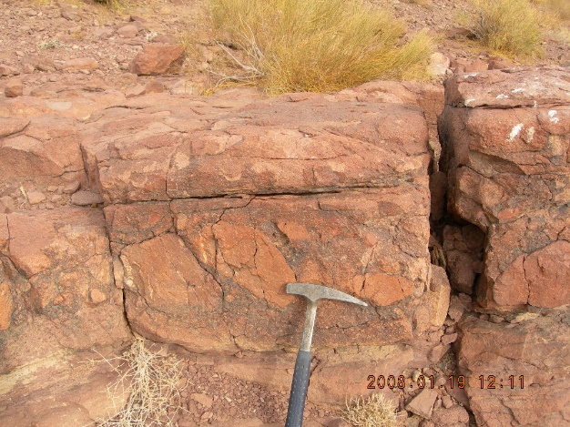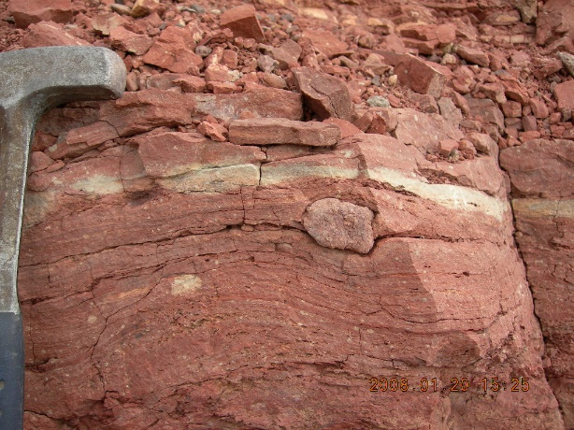
Possible glacial diamictite in the Naghr Formation to the east of Duba (l) and possible dropstone. An ash from the Dhaiqa region to the south, dated at @565 records the youngest of the Neoproterozoic glaciations, also noted in the Cadomian orogeny of the NE Bohemian Massif and SW Iberia, a post-Gaskiers glacial event.

