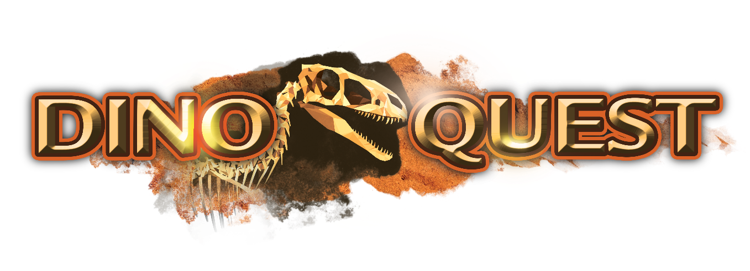

Exhibition Overview
THE CLOSEST YOU WILL EVER COME TO DINOSAURS – DEAD OR ALIVE
DinoQuest is a travelling exhibition developed by Science Centre Singapore, Dezign Format, Digimagic and world renowned female palaeontologist Professor Patricia Vickers – Rich.
DinoQuest is one of the most exciting and educational dinosaur themed exhibition ever to go on the road and it promises to bring visitors on a great adventure. It aims to wow the audience by creating an experience of the amazing discovery of dinosaurs in Australia. The exhibition is presented using the latest in interactive technology coupled with creative storytelling.
DinoQuest is a 1,200 square metres exhibition which consist of 7 Zones each offering a different thematic experience:

a) Explorer’s Hut
A diorama projection show of how Australia’s first dinosaur fossil is discovered. Visitors will also register their RFID i-DinoTag, where they will be randomly assigned a dinosaur fossil to discover.

b) Dinosaurs of Darkness
Through a projection show coupled with animatronics, visitors will travel back millions of years ago and explore Australia in the early cretaceous period.

c) Extinction Cave
An immersive 4D theatre that will provide visitors a glimpse of what caused the dinosaur to become extinct.

d) Dig Site
Recreation of an actual dig site. Here, visitors will explore topics like the geological timeline, the fossilisation process, how dinosaur bones are excavated, and the various processes / tools that palaeontologists use in the dig site.

e) Laboratory
Find out what happens after bones are being excavated; how scientist figure out what the dinosaurs look like just from a few bones, and how they prepare the fossils from the rocks.

f) Dinosaur Dreaming
See displays of fossils and appreciate the amount of commitment and effort that palaeontologist put in to excavate these fossils.

g) Dino Playground
Fun and interesting zone to end off the experience. For example, visitors can doodle and draw their dinosaurs and send them off to the virtual Dinosaur Park.

Requirements for Setup
To be provided by client:
- Accommodation (3* and above)
- Airfare (Economy Class)
- Per Diem (US$60/day) for 10 persons
- Professional Fees: US$7,200
- 8 general manpower
- 1 certified electrician
- 1 media/AV professional
- Provision of internet access within the exhibition
- Power supply – 220V

Hosting the Experience
- Lease Fees: US$80,000/month, minimum lease period of 3 months
- Minimum area requirement: 1,200 square metres
- Minimum height requirement: 5 metres
- 8 containers (2-way freight to be borne by client)

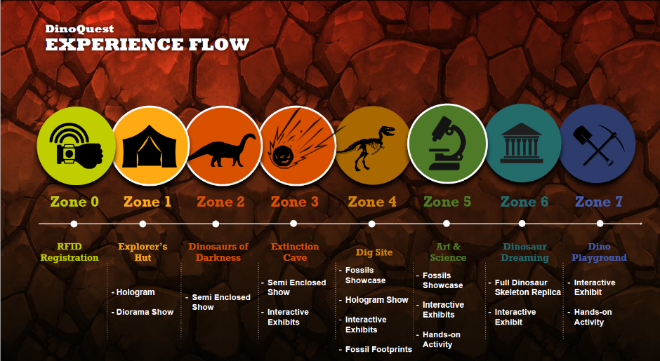
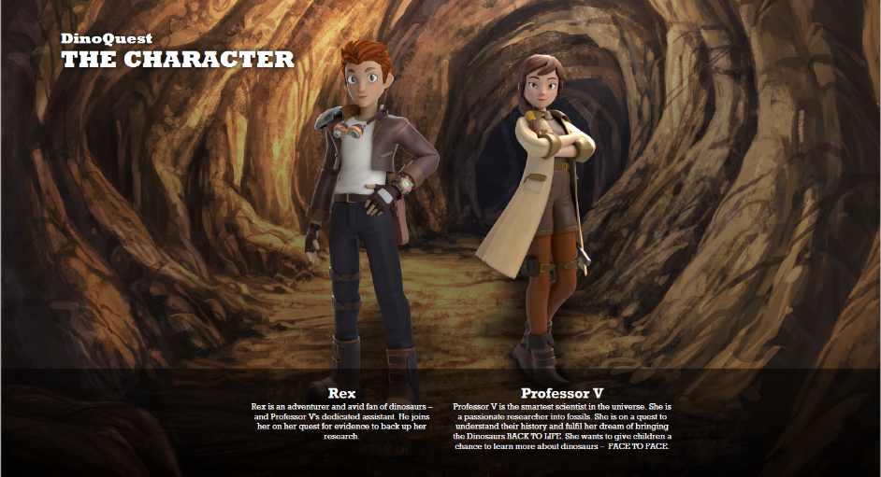

Zone 0 – DinoQuest Registration
Description: Sign up to join Prof V and Rex on the Dino Quest!
Remarks: Visitors are assigned a RFID Tag which they will register here
Exhibits | - Thematic Entrance Statement  - DinoQuest Registration Kiosk – 6 Kiosks  - Entrance Animatronics Logo  - Character stats introduction TV
Facility Requirements | - Power Supply  - WiFi Network Connection
Dimensions | 100sqm
Photos | 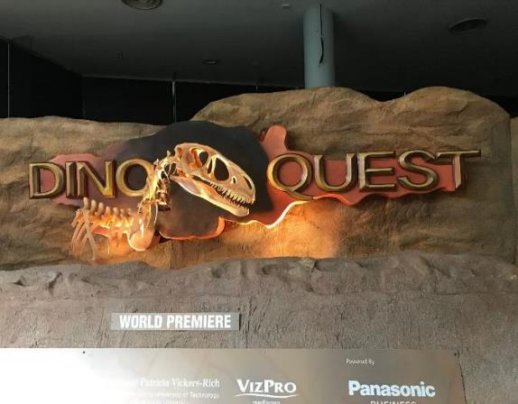  Moving Animatronics Logo  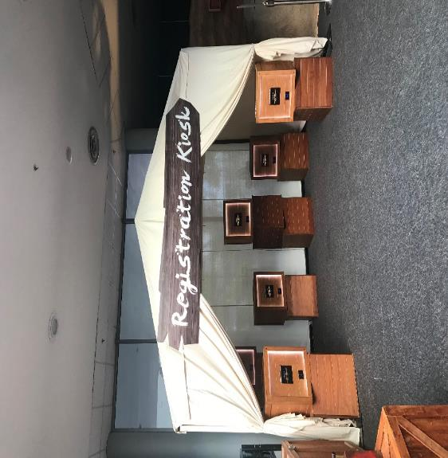  Registration Kiosk Tentage  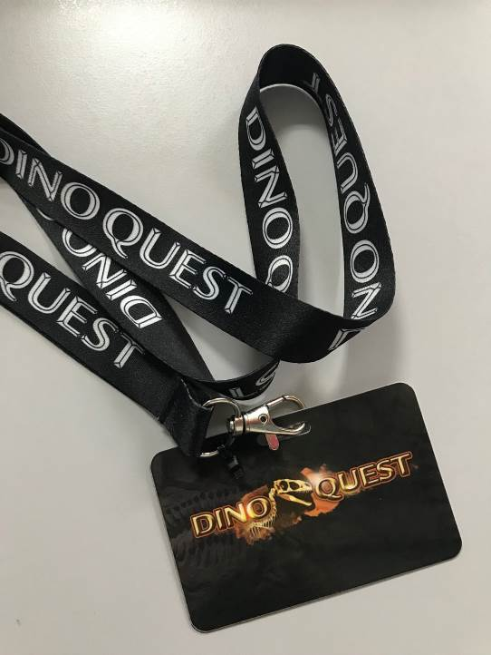  I-Dino Tag

Zone 1 – Explorer’s Hut
Description: At the start of the epic exhibition, guests will be introduced to their holographic guides, Professor V and her assistant Rex, through a Diorama Projection show that showcases how Australia’s first dinosaur fossil was discovered. Guests will also register their RFID i-DinoTag to kick-off the quest to uncover the Polar Dinosaurs of Australia.
Exhibits | - Thematic Environment – Tentage setting, with 3D props  - Object Theatre Show with Holofans for introduction of Main Characters  - Fossil Collection Kiosks – 5 Kiosks  - Time Tunnel
Facility Requirements | - Power Supply
Dimensions | 131sqm
Photos | 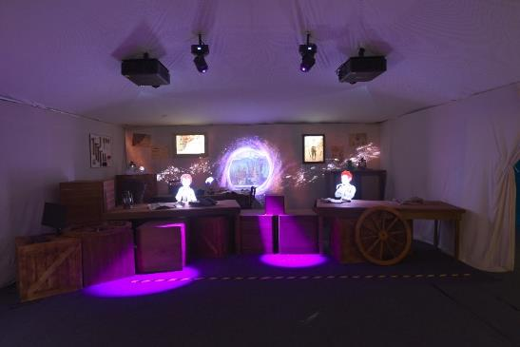  Zone 1 Object Theatre Introduction Show  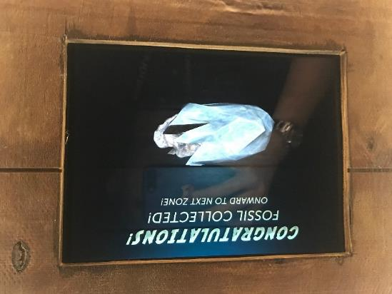  Fossil Collection Kiosk  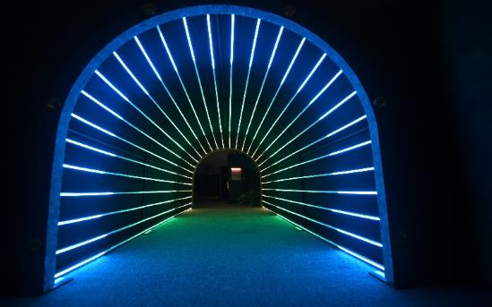  Time Tunnel

Zone 2 – Dinosaurs of Darkness
Description: Through a projection show coupled with animatronics and 4D elements, visitors will travel back millions of years to explore Australia in the early cretaceous period. Take a tour into the world of dinosaurs and come face to face with prehistoric creatives including the Koolasuchus, Ankylosaur, Leaellynasaura, Pterosaur and Timimus, learning more about their habitat, behaviour and diet!
Exhibits | - Zone Introduction Holofan  - 16m long screen with 5 Animatronics Dinosaurs  - Zone RFID Kiosks – 3 Kiosks
Facility Requirements | - Power Supply
Dimensions | 210sqm
Photos | 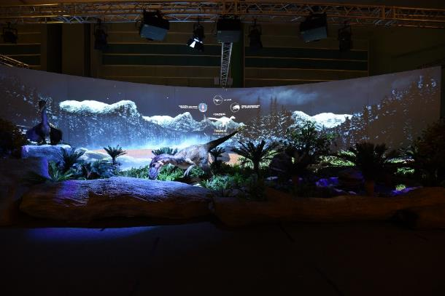  Zone 2 Object Theatre Show  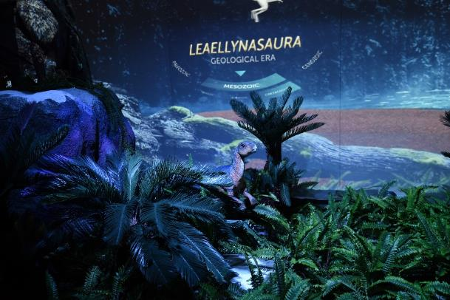

Zone 3 – Extinction Cave
Description: In an immersive 4D theatre, experience the disaster that wiped out dinosaurs in an apocalyptic display of volcanic eruption and meteorite strikes amplified by sound effects, smoke and atmospheric lighting.
Exhibits | - Zone Introduction Holofan  - Object Theatre  - 3 animatronics – Ceratopsian(Show animatronics), Atlascopcosaurus Loadsi, Megaraptoran
Facility Requirements | Power Supply
Dimensions | 88sqm
Photos | 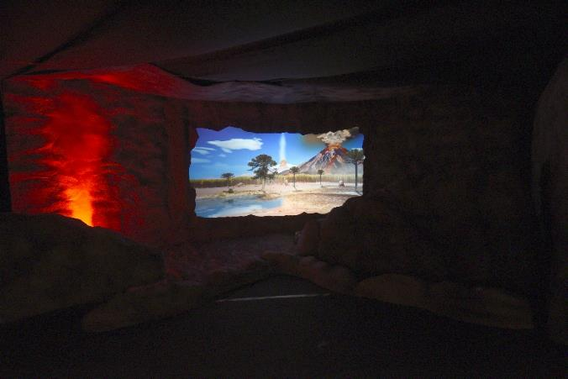  Zone 3 Object Theatre Show  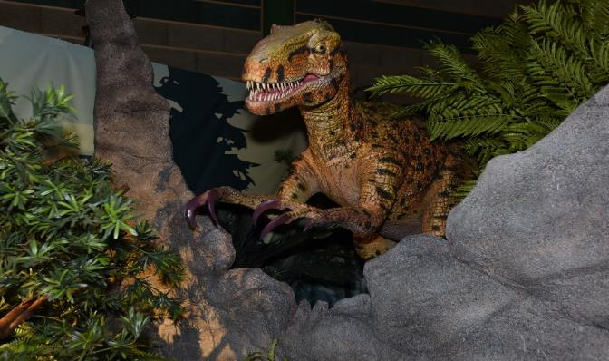  Megaraptoran

Zone 4 – Dig Site
Description: A recreation of an actual dig site, guests can experience more about the science of palaeontology and the process of fossilisation. Through a hologram show, discover how dinosaur fossils are formed and learn to identify different parts of their anatomy. Find out if you have what it takes to be a Dinosaur Detective!
Exhibits | - Zone Introduction Holofan  - Fossilisation Hologram of Leallynasauras – Animation of the fossilisation process  - Geological Timeline - Thematic alcoves where you can learn about the environment and creatures that inhabited that geologic era in time.  - Tree of Life animation - Summary animation on the evolution of life.  - Dig Site 1 – Dead Tarbosaurus fossil display  - Dig Site 2 – Footprints  - Dinosaur Cove – 2 interactives (Detonator and Jackhammer)  - Zone RFID Kiosks – 5 Kiosks
Dimensions | 351sqm
Photos | 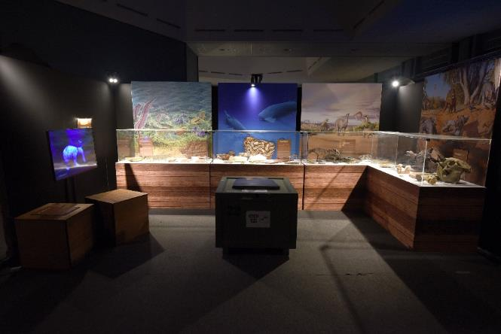  Geological Timeline Fossil Display  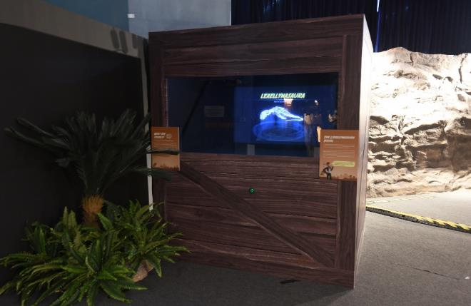  Animation of Fossilisation Process  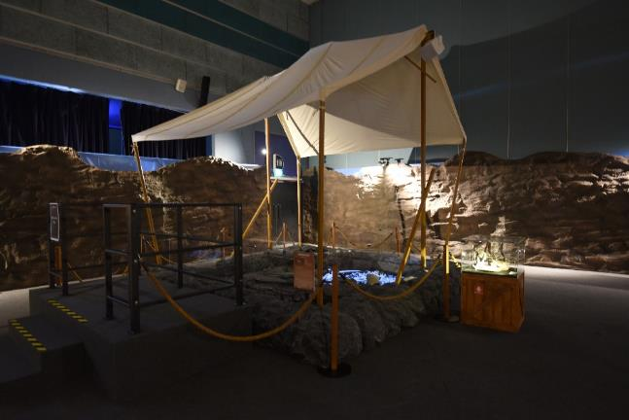  Tarbosaurus Dig Pit  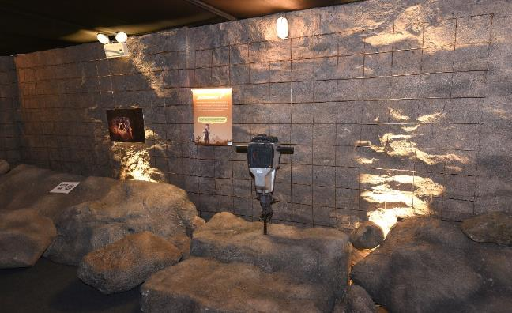  Interactive Jackhammer

Zone 5 – Laboratory
Description: In a re-creation of a palaeontologist’s high-tech laboratory, guests can witness the exciting dinosaur preparation process featuring actual equipment and tools. At the Giant Megalania Alive Studio, experience how 3D Holographic Mapping can bring the creature to life. Don’t miss out on the hands-on activity at the Bone Station where guests can drill into rocks from Dinosaur Cove to discover actual fossils!
Exhibits | - Zone Introduction Holofan  - More than Dinosaur Bones – Environmental Fossils, Bird Skeleton vs Dino Skeleton  - Specimens Display – Stones, Layers, Tooth vs Tooth, Tooth vs Claw, Wentzscope Viewer, Plaster Jacket  - Lab Preparation Setting  - Lab Extraction Hands-on Drilling Activity  - Megalania Holo Viewer  - Rotoscope – Progression of Discovery Animation of Iguanodon  - Peter Trusler’s Studio  - Zone RFID Kiosks – 5 Kiosks
Facility Requirements | - Power Supply
Dimensions | 180sqm
Photos | 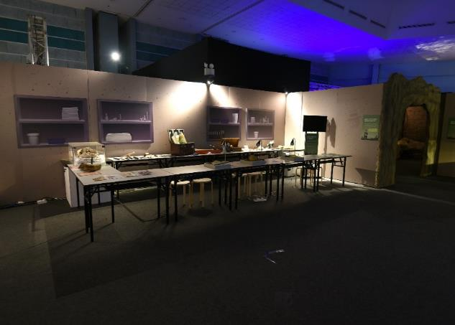  Fossil Preparation Laboratory  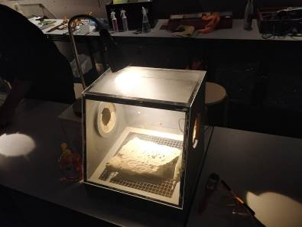  Fossil Preparation Hands On Activity  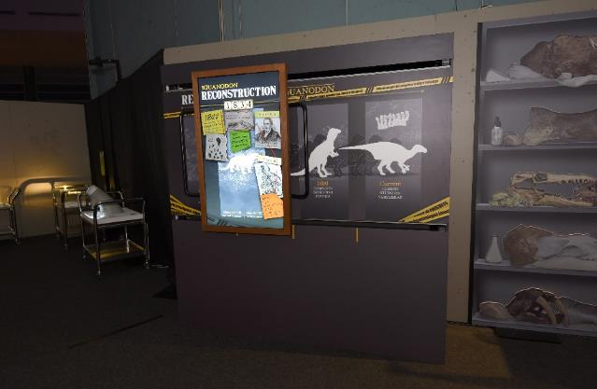  Rotoscope – Iguanodon Reconstruction  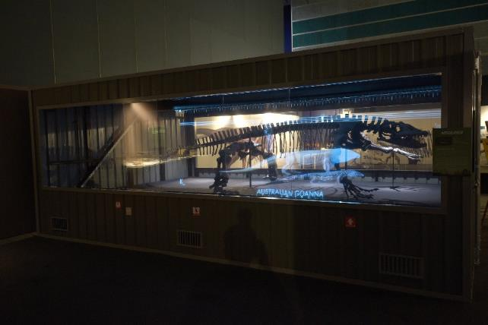  Megalania Holo Viewer  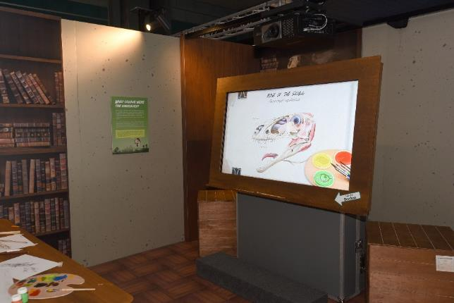  Peter Trusler’s Studio

Zone 6 – Dinosaur Dreaming
Description: Here, guests will be welcomed by a replica display of dinosaur skeletons found at Dinosaur Cove including the worldwide premiere of the most updated reconstruction of Timimus, a tyrannosauroid discovered at Dinosaur Cove in 1994. Take a journey across time and be enthralled by the myriad of colours and forms of the natural history specimens from the time of the great extinction. Uncover fossils amplified through rotating AR interactive touch screens and discover the living dinosaur descendants of today.
Exhibits | - Zone Introduction Holofan  - Specimen Display – Hypsilophodontid, Ankylosaurus, Allosauroid, Koolashuchus(Labyrinthodont), Pterosaurs, Protoceratopsian, Cryoloshosaurus, Timimus, Mammals  - Little L story book  - Zone RFID Kiosk – 5 Kiosks
Facility Requirements | Power supply
Dimensions | 237sqm
Photos | 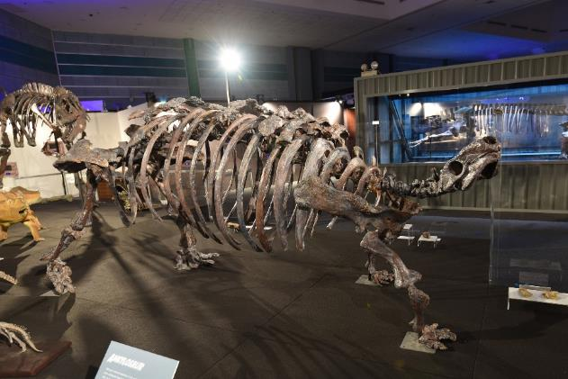  Specimen Display  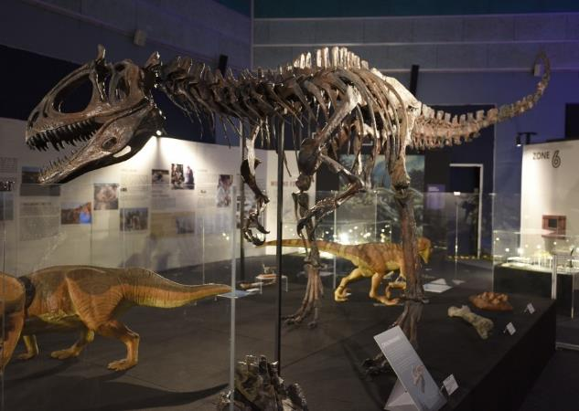  Specimen Display  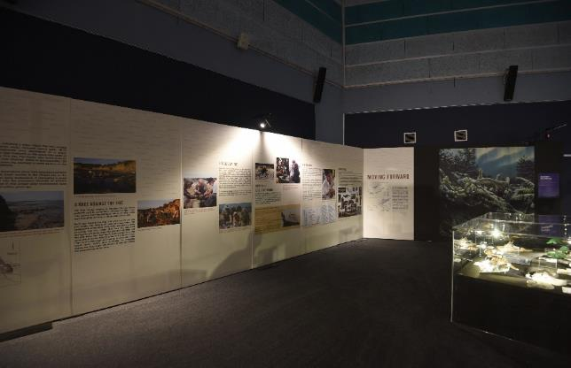  Dinosaur Cove Excavation Milestones  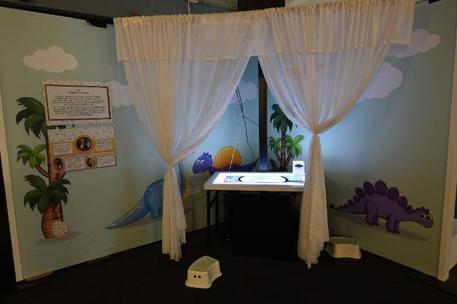  Little L Room

Zone 7 – Dino Playground
Description: The journey comes to a close with another hands-on activity zone where guests can create new dinosaur species by doodling and bringing it to life at the virtual animated Dinosaur Park. Draw imaginary dinosaurs, fill them with colour and swipe them into the projection screen to watch it join in the fun with other original dinosaur creations!
Exhibits | - Zone Introduction Holofan  - Dino Peekture  - Dino Doodle – 2 Printing Kiosks and 1 Scanning Kiosk  - Certificate Printing Kisok
Facility Requirements | Power Supply
Dimensions | 230sqm
Photos | 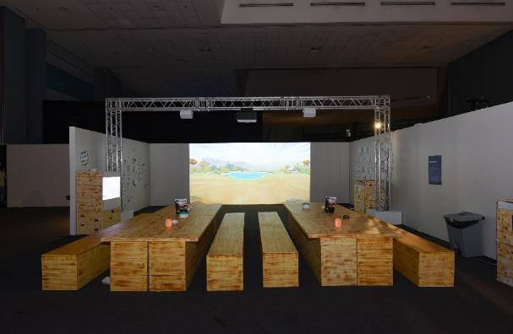  Dino Doodle  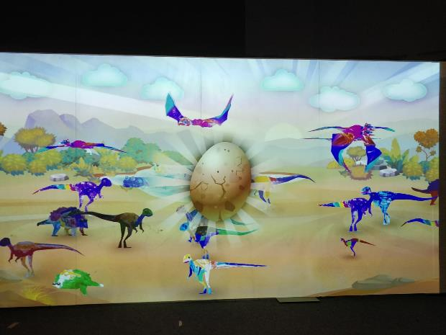  Dino Doodle Animation  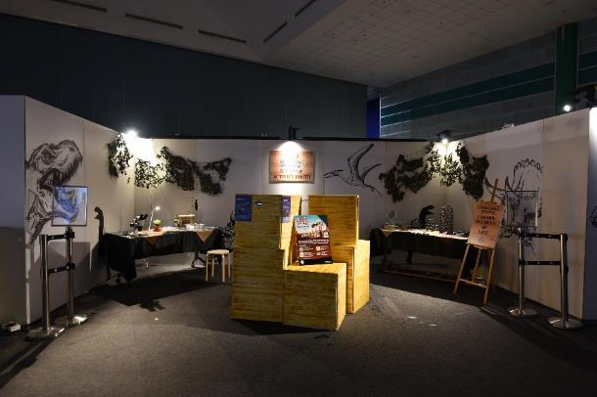  Survivors Menagerie – See the descendants of the dinosaurs  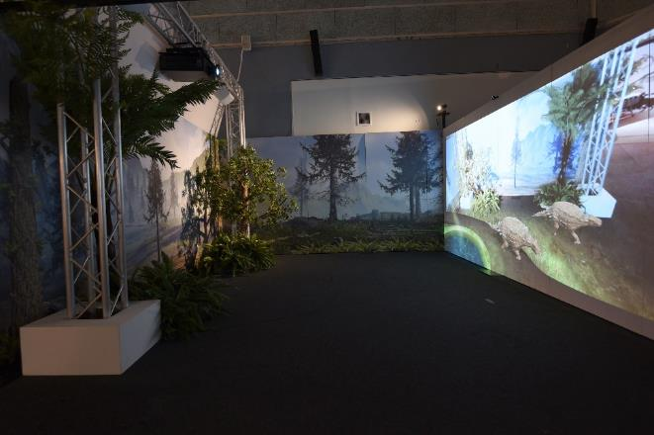  Peek-ture – Take a photo with the virtual dinosaurs

