ACTIVITIES OF IGCP 673 FOR 2019
- FIELD CONFERENCE 1, DOCUMENTARY PRODUCTION. SOUTHERN NAMIBIA, 4 – 12 MARCH 2019.

List of Participants  01 | Schröder-Ritzau, Andrea | Heidelberg, Germany
02 | Eichstädter, René | Heidelberg, Germany
03 | Rojo-Perez, Esther | Madrid/Spain
04 | Cantine, Marjorie | Cambridge, MIT, USA
05 | Avigad, Dov | Jerusalem, Israel
06 | Gerdes, Axel | Frankfurt, Germany
07 | Plessen, Birgit | Potsdam, Germany
08 | Ovtcharova, Maria | Geneve, Switzerland
09 | Fabio Messori | Geneve, Switzerland
10 | Gärtner, Andreas | Dresden, Germany
11 | Geyer, Gerd | Würzburg, Germany
12 | Roper, Richard Albert | Frankfurt/Madrid/Germany, Spain
13 | Raddaz, Jacek | Frankfurt, Germany
14 | Hofmann, Mandy | Dresden, Germany
15 | Zieger, Johannes | Dresden, Germany
16 | Walker, Achim | Dresden, Germany
17 | Walker, Birgit | Dresden, Germany
18 | Linnemann, Ulf | Dresden, Germany
19 | Vickers-Rich, Pat | Melbourne, Australia
20 | Steve Pritchard | Melbourne, Australia
21 | Helke Mocke | Windhoek, Namibia
22 | Kombada Mhopjeni | Windhoek, Namibia

Excursion plan
March 4: day of arrival, in the afternoon visit of the Namibian Geological Survey
3.00 pm: Introduction and visit of the collections (Helke Mocke, Pat Vickers-Rich, Ulf Linnemann)
5.30 pm: Open lecture of Axel Gerdes “U-Pb dating of limestone”
March, 5: drive to Aus (700 km), some outcrops on the road side
March, 6: Snowball Earth sediments around Rosh Pina
March, 7: Precambrian-Cambrian boundary at farm Swartpunt
March, 8: Precambrian-Cambrian contact at farm Swartkloofberg
March, 9: Ediacaran sediments and fossils at farm Aar
March, 10: Ediacaran sections at farms Anusi and Pockenbank
March, 11: drive back to Windhoek (700 km), some outcrops at the roadside
March, 12: day of departure
Geological map of southern Namibia and the Nama basin (Grotzinger and Miller, 2008)

Fossils from the Swartpunt and Swartkloofberg sections. A – Cochlichnus isp.; from Nomtsas
Formation, unit G. B – Shallow horizontal burrows resembling Harlaniella, with different types
of annulations (arrows) suggesting a spiral burrow; Spitskop Member, unit F, metre 127. C –
Trace fossil assemblage with simple Planolites-type horizontal traces (from Linnemann et al.,
2019).

During the excursion, filming was underway by doco maker Steven Pritchard to produce the 1 minute record of IGCP Project 673, which is to later be expanded into a full length production. His task was to document the landscape, the geological succession and interview the experts on this trip who are participants in this UNESCO International Geological Programme Project. That documentary is attached with this report.

A soft copy of the excursion guide is provided with this report. It not only includes detailed information on the excursion itself but copies of several papers and a copy of the excursion guide crafted for the pre-conference excursion for the 35th International Geological Congress in 2016 – The Nama Group of Southern Namibia – The End Game of the First Large, Complex Organisms on Earth, the Ediacarans [IGCP493/587].

Original papers in the Appendix and appropriate day of use:
March, 5: drive to Aus
Fish River Group: Appendix 1_Geyer (2005)
March, 6: Snowball Earth sediments around Rosh Pina
General geology Gariep belt: Appendix 2_McDonald et al. 2010
Snowball Earth: Appendix 3_Hofmann et al. 2013, Appendix 4_Hofmann et al. 2014
March, 7, 8: Precambrian-Cambrian boundary at farm Swartpunt and incised valleys of the earliest Cambrian at farm Swartkloofberg
Precambrian-Cambrian boundary and incised valleys: Appendix 5_Saylor & Grotzinger, 1996; Appendix 6_Linnemann et al., 2019
C-isotopes: Appendix 7_Wood et al. 2015
March, 9, 10: Ediacaran sediments and fossils at farms Aar and Pockenbank
Ediacaran Fossils: Appendix 8_Vickers-Rich et al. 2013, Appendix 9_Vickers-Rich et al. 2016
Geology: Appendix 10_Hall et al. 2013

2. FIELD CONFERENCE 2, FIELD AND LABORATORY RESEARCH. SOUTHERN NAMIBIA, 1 JULY-6 AUGUST 2019.
Leaders: Profs Mike Hall (Monash University), Patricia Vickers-Rich (Monash University and Swinburne University of Technology) (in cooperation with the Namibian Geological Survey, and the Scientific Societies in Windhoek and Swakopmund. Other team members for this work included Dr Tom Rich from Museum Victoria, Peter Swinkels from Monash University, Ms Helke Moeke and Ms Kombada Mhopjeni from the Namibian Geological Survey, Milton Bampton from Aus Marble and locals Berndt Roemer, Barbara Boehm-Erni and Lother Gessart.
Purpose: To pull together decades of sedimentological research data and correlate with the palaeontologic, geochemical and palaeogeographic data for the southern Namibian sequences that record the transition in time from the late Neoproterozoic into the modern world of the Cambrian, a time of profound change in the history of life on Earth. To film for a documentary using this data base, the filming of which has been underway since 2017 with documentary maker Steven Pritchard.
1 July – 6 July 2019. Windhoek, examination of both the palaeontological collections and data in the Namibian Geological Survey with the assistance of staff members Helke Moeke and Kombada Mhopjeni and information on the human history of the Aus region in cooperation with the staff at the Namibian Scientific Society, especially Gunter von Schumann. Was able to access the records in the National Archives concerning the Indigenous and European inhabitants of the region around Aus from around 45,000 years to present. During this time in Windhoek, Vickers-Rich presented an evening lecture to the Namibian Scientific Society on 3 July 2019 on the Ediacaran research carried out over the past decade and a half in southern Namibia: “From Biotic Weirdness to the Modern World.”
7 July – 27 July 2019. Documentation of the stratigraphic sections in the region to the east and south of Aus which record the transition from the late Neoproterozoic into the Cambrian. Several of the local farms were investigated, including Aar, Kubub, Arasab (Theodora), Pockenbank, Kokerboomkloof, Anib, Anusi, Swartpunt, Sandykop, and Swartkloofberg. Some new fossil material was located on Pockenbank, and an effort was made to collect some of the carbonate fossils on Aar and Pockenbank in particular. With the assistance of access provided by staff from Aus Marble (Milton Bampton) material was collected from Swartkloofberg, including some of the first hard shelled organisms Namacalathus, and sedimentological data was added to the data base from this late Neoproterozoic site with some of the first massive reefs on record, the Pinnacle Reefs.
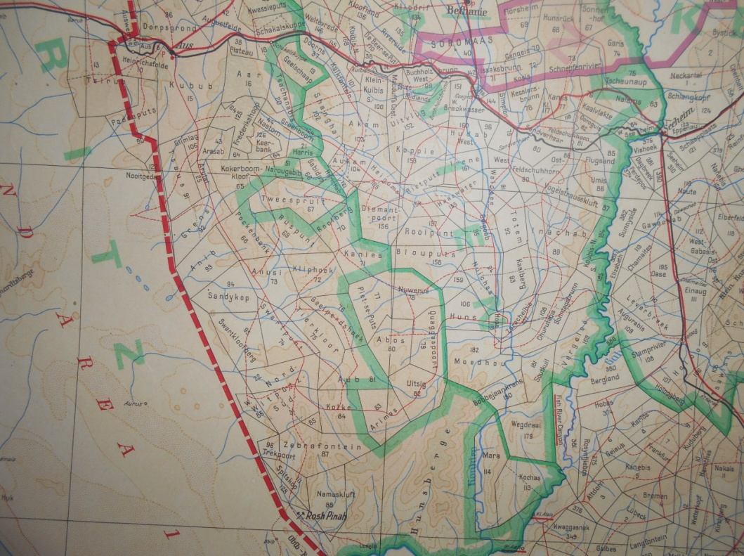
On Pockenbank Pteridinium was found in both the Aar and Kliphoek members, and one specimen found at the top of the Kliphoek appeared to have a holdfast attachment. While staff from the Namibian Geological Survey were with the team, a detailed investigation of the region on Aar near Ernietta Hill that has produced the taxon Ernietta in abundance in several different taphonomic settings was carried out that produced an outline for a PhD thesis. A small collection of samples of Cloudina were gathered and will be thin sectioned at Monash.
During the research time in the Aus region discussion continued concerning the setup of a local museum in Aus that would service tourism and the local schools, discussions between the owners of the Bahnhof Hotel, Klein Aus Vista and the owner of Farm Aar. As a result of those meetings and discussions, material that had been in storage of Ediacarans was assessed and those appropriate transported to Klein Aus Vista with the intention of within the next few months to set up a small display at their facility. Prof Vickers-Rich provided the panels and the labels for these specimens. Other specimens were packed for transport to the Museum in Swakopmund that is overseen by the Namibian Scientific Society group based there, of Dr Gabi Schneider and Nadine Moroff. The specimens included Pteridinium, Ernietta, Nemiana, stromatolites and trace fossils – all from the late Neoproterozoic of southern Namibia, and will be on loan from the National Earth Science Collection managed by the Namibian Geological Survey based in Windhoek and curated by Ms Helke Moeke. As with the small collection to be displayed at Klein Aus Vista, Vickers-Rich provided the panels and labels for the Swakopmund Museum display and will work with this museum and those in Aus and Luderitz in 2020 to outfit.

The Swartkloofberg section on Farm Swartkloof (c. 85 km south of Aus). Position of lithostratigraphic unit G
of the Nomtsas Formation indicated (Linnemann et al., 2019).

28 July – 1 August 2019. With the guidance of Milton Bampton the team moved north to Walvis Bay and Swakopmund. Along the way, video footage was taken of the changing geological landscape from Aus to Walvis Bay via Solitaire. Then upon arrival after the 28th of July, we were able to visit the storage facility of Aus Marble and inspect the blocks of carbonates that have been mined over decades from a variety of quarries around Namibia. In Swakopmund we were also able to work with Gunter von Schuman, Dr Gabi Schneider (Director of the Namibian Uranium Association, past director of the Namibian Geological Survey and now an associate of the Swakopmund Museum overseen by the Scientific Society) and Curator there Nadine Moroff on both the geological and human history of southern Namibia. Plans were discussed for me to return in March 2020 to work with Dr Schneider and Ms Moroff to upgrade the palaeontological section of this small but stunning regional museum. exhibits discussed are to cover the complete geologic history of central and southern Namibia from the Precambrian through to Present and will facilitate the bringing in of related fossil material from the prehistory supercontinents of Gondwana and Rodinia. On 31 July 2019 presented another public lecture for the Scientific Society in Swakopmund at the headquarters of the Namibian Uranium Association which covered the research that my UNESCO International Geoscience projects 493, 587 and the current 673 have investigated since the early 2000’s. The audience included, as did that in Windhoek, a wide range of attendees from professional geologists, to marine biologists, tour guides and a variety of locals, with excited primary kids.
Another topic of discussion with Dr Schneider and others at the Namibian Scientific Society, a continuation of the discussions in Windhoek and Aus, was the crafting of a proposal to UNESCO for designation of several properties in southern Namibia for recognition as World Heritage – from Farm Aar in the north to Fish River Canyon in the south. The National Heritage Council of Namibia has already given a Notice of Inclusion of Farm Aar in the Namibian National Heritage Register published in the Government Gazette No. 4787 (notice no. 155) dated September 1 2011. All future work on this property requires a permit from the National Heritage Council, which already gives it some protection. What is sorely needed is a permanent Ranger funded to be present always on this and adjoining properties which hold the best record for the planet of this time of transition from the Ediacaran/Vendian biota of the late Precambrian to one of the modern biota that dominates the planet for the last 538+ million years. It is hoped that this World Heritage proposal will be submitted by the end of 2020.
1 August – 6 August 2019. Drove mid-day from Swakopmund to Windhoek and once in Windhoek, spent the time curating the specimens that we had collected this season as well as integrating material that had been in the temporary collections in Aus. Since my team and I began work in the early 2000’s the collection in the Namibian Geological Survey Earth Sciences, and at that time the total collection of Ediacaran material in the collection filled two cabinets. Since then our collection has expanded into 18 more cabinets and after the addition of the material brought back to the Survey, the head Curator Helke Moeke has indicated that she will add 4 more cabinets by the time we return next March. I have offered and it has been accepted that I will curate all this new material. We also discussed the possibility of Moeke and Mhopjeni embarking on PhD programmes with me, one dealing directly with a palaeontological/taphonomic problem with the taxon Ernietta and the latter working on science communication. By the 7th of August all the team had returned to Melbourne.

