[Date]
Dear Dr [INSERT NAME]
75% of your patients were recommended a surveillance colonoscopy interval consistent with the NHMRC guidelines. The target is 80% guideline concordance.
Why am I receiving this report? | This report contains feedback on your concordance with the NHMRC-endorsed Cancer Council Australia Surveillance Colonoscopy Guidelines^{1,2} as a part of [HEALTH SERVICE] quality improvement program conducted between [INSERT AUDIT PERIOD e.g., 01/04/2024 to 30/06/2024].
What is my performance? | Your surveillance interval recommendations for audited cases shows that 75% of your patients had an interval consistent with the guidelines.  This is 5% lower than the target guideline concordance (figure).
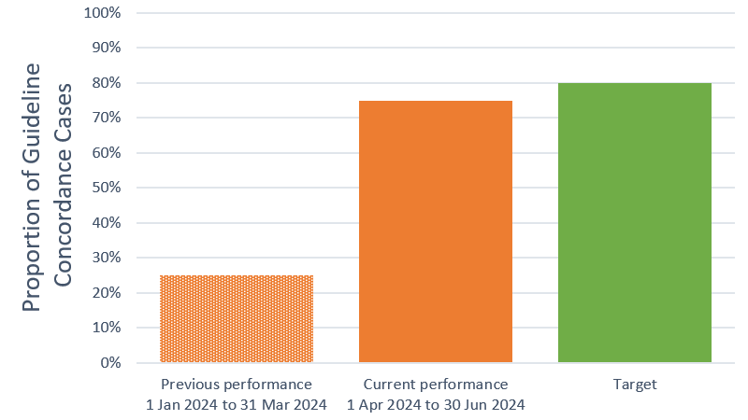
What should I do with this information? |  | More information on your guideline concordance and patient details for non-concordant cases is provided in the tables overleaf.  We invite you to reflect on your data and consider whether there are opportunities for you to harmonise your interval recommendations with best practice guidance^{1,2}.
How can I improve my guideline concordance? |  | Visit the Value In Care – optimising surveillance COLonoscopy (VIC-COL) website to access best practice resources, including guidelines, patient resources and webinars on surveillance colonoscopy (https://www.monash.edu/medicine/sphpm/units/clinical-epidemiology-cabrini/vic-col)  Use Polyp.app, a tool to support guideline uptake (https://polyp.app/ or QR code)  Consider the details of your non-concordant cases (Table 2) and whether guideline-recommended intervals may be appropriate for these and other future like cases  Take the opportunity to educate your patients about the benefits, harms and best practice guidance for surveillance colonoscopy | 
How will I benefit from this? |  | Time spent reviewing this feedback and exploring improvement opportunities will contribute towards your annual AHPRA Continuing Professional Development (CPD) requirement.

We hope you have found this information useful. If you have any questions or suggestions on how we can improve this feedback, please contact:
[INSERT REPRESENTATIVES OF THE HOSPITAL QUALITY IMPROVEMENT OR AUDIT TEAM HERE]

References
¹ Cancer Council Australia (2018). Cancer Council Australia Surveillance Colonoscopy Guidelines Working Party. Clinical practice guidelines for surveillance colonoscopy. https://www.cancer.org.au/clinical-guidelines/bowel-cancer/surveillance-colonoscopy
² Cancer Council Australia (2023). Cancer Council Australia Colorectal Cancer Guidelines Working Party. Clinical practice guidelines for the prevention, early detection and management of colorectal cancer. https://www.cancer.org.au/clinical-guidelines/bowel-cancer/colorectal-cancer

Table 1. Timing of your surveillance interval recommendations for this period [INSERT DATES FOR AUDIT PERIOD] compared to the NHMRC guidelines. [ADDITIONAL COLUMNS AND RESULTS MAY BE ADDED TO TABLE 1 WHEN NEW AUDIT DATA BECOME AVAILABLE]
Timing of your interval recommendations compared to the guidelines | CURRENT PERIOD  [e.g., 1 Apr to 31 May 2024]  % (n) | PREVIOUS PERIOD  [e.g., 1 Jan to 31 Mar 2024]  % (n)
Concordant | 75% (6) | 25% (4)
Early | 0% (0) | 50% (8)
Late | 25% (2) | 25% (4)
No surveillance recommended | 0% (0) | 0% (0)
Table 2. Individual patient data for the current period
Highlighted in bold are cases where there is a discrepancy between your recommendation and the guidelines. Please note that only you receive this data.
Patient URN | Procedure date | Your recommendation | Guideline recommendation
[insert URN HERE e.g., 010115] | 18/04/2024 | 10 years | 10 years
010117 | 23/04/2024 | 10 years | 5 years
[] | 23/04/2024 | 3 years | 3 years
[] | 25/04/2024 | 3 years | 3 years
[] | 14/05/2024 | 5 years | 5 years
[] | 14/05/2024 | 3 years | ≤1 year
[] | 28/05/2024 | 5 years | 5 years
[] | 18/06/2024 | 5 years | 5 years

Details of non-concordant cases:
Patient URN: | 110117
Current colonoscopy findings
Type of polyp: | Conventional adenoma removed
Number of polyps: | 3-4
Size of polyps: | <10mm
High grade dysplasia or villosity: | No
Is this index colonoscopy: | Yes
Endoscopist recommendation: | 10 years
Guideline recommendation: | 5 years
Notes:

Patient URN: | [INSERT URN HERE]
Current colonoscopy findings
Type of polyp: | Conventional adenoma removed
Number of polyps: | 5-6
Size of polyps: | ≥10mm
High grade dysplasia or villosity: | No
Is this index colonoscopy: | Yes
Endoscopist recommendation: | 3 years
Guideline recommendation: | ≤1 year
Notes:

