

DOUBLE MASTER IN INTERPRETING AND TRANSLATION STUDIES

APPLICATION FORM

This application form is for applicants who wish to apply for entry into the Double Master program that the Monash University Master in Interpreting and Translation Studies has with three other Master programs at universities in France, Italy and Japan.

Please note that this application form is an application form for the Double Master program only and that applicants need also to apply for admission to the Monash University Master in Interpreting and Translation Studies concurrently:

http://www.monash.edu.au/study/coursefinder/course/A6007/

I would like to apply for entry into the Double Master program with the following partner university (please select one only):

University of Bologna, Italy (Double Master in Translation)



University Jean Moulin, Lyon, France (Double Master in Translation)

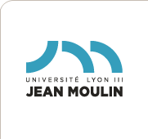

Kobe City University of Foreign Studies, Japan (Double Master in Interpreting and Translation)

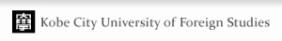

Once completed, this application form and the copies of the required documents should be sent to:

Arts Student Services
Faculty of Arts
Monash University
Clayton VIC 3800
Australia

Email: arts-international@monash.edu

Once your application has been processed, you will be contacted with further information.

Required documents:

- Photocopies of your academic transcripts

- A current curriculum vitae

- A covering letter supporting your application

Surname:

Given Name/s:

Date and Place of Birth:

Nationality:

Postal Address:

Telephone:

Email:

Mother Tongue:

Other Languages:

Language Direction (for translation):

From English into LOTE (Language other than English)

From LOTE (Language other than English) into English

Education:

Professional Experience :

Do you have any experience in professional translation and/or interpreting? If yes, in what circumstances? (Please attach evidence where possible.)

Have you ever lived in a country other than Australia? Which and for how long?

