Crossing the Line

The Ediacaran – Cambrian Transition in Southern Namibia – How the World Began to Change @ 538 million years ago.

P. Vickers-Rich with M. Hall, U. Linnemann, M. Hofmann, A. Kaufman, G. Narbonne, M. Fedonkin, A. Ivantsov, P. Trusler, S. Pritchard, A. Sharp, D. Elliott, H. Cui, S. Darroch, M. Laflamme, J. Smith, P. Swinkels, L. Kriesfeld, C. Hoffmann, H. Mocke, K. Mhopjeni, T. Rich and G. Schneider.

ABSTRACT

Namibia hosts a near complete sequence of sediments and volcanics that record a period from the late Neoproterozoic into the early Phanerozoic (600-500 million years) when the biota on planet Earth changes from one of enigmatic life to what we consider normal today, including the appearance of Animalia – forms with eyes, guts, the ability to move and even hard skeletons. Researchers in Namibia, over the past few decades, showcasing those early complex, megascopic lifeforms, the Ediacarans, some the predecessors true animals, have been able to more precisely date just when this transition occurred and what were the environmental drivers to this change. This research continues now with a global network of researchers continuing to add to the ever-increasing database, critical to understanding the interaction of life and changing environmental conditions, relevant to predicting the future of Planet Earth.
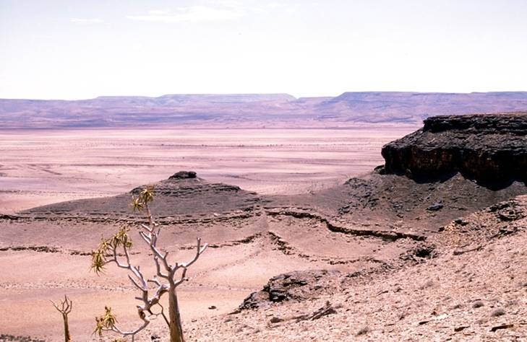

Fig. 1. The Nama Group of Southern Namibia hosts a rich collection of Ediacaran organisms, a
group that prospered more than 530 million years ago, prior to the appearance of true animals
on planet Earth.

Namibia has been a key region for understanding some weird organisms called Ediacarans since early days of the 20th century, when geologists, such as Paul Range and German soldiers posted at isolated outposts in the Aus region of southern Namibia, first reported strange fossils from there. These were the first large multicellular organisms that prospered on planet Earth before the development of animals. Their fossils are preserved in the thick rock sequences in Southern Namibia and showcase a time in the history of life when there were fundamental and pivotal changes from an enigmatic biota to what we consider normal today.

The first formal name for one of these complex Ediacaran life forms from the Nama Group rocks of Namibia, was given by Gürich in 1930. He proposed the name Rangea schneiderhoehni for fossils of the enigmatic, cm-scale frond-like organism collected from the Dabis Formation in the south of the country. Rangea predated Sprigg’s

(1947) description of Dickinsonia from the Flinders Ranges in Australia by nearly two decades. Dickinsonia fossils also formed part of the Ediacara biota and this official name for the geological period was based on these fossils

from Ediacara. Likewise, the official naming of other Ediacaran fossils in Ford’s (1958) description of Charnia from Charnwood Forest in England was nearly three decades after Gürich’s seminal paper. This Namibian fossil was not a simple disc that could be described and then forgotten – it was a frond covered with features so complex that Gürich assumed Rangea must be of a younger Cambrian age, a time period well known by then, especially from rocks in England and Europe, that hosted true skeletonized animals – trilobites and shelled forms related to clams and snails.

It has been more than 90 years since Gürich’s naming of Rangea and since that time a variety of other Ediacaran forms have also been named and become bell-weather taxa for our changing interpretations of what we call the Ediacara biota. Rangea was originally regarded as a primitive relative of the ctenophores or corals (Gürich, 1930, 1933; Dzik, 2002, Richter, 1955; Jenkins, 1985, 1992). Much later, researchers such as Seilacher and his colleagues (Seilacher, 1992; Grazhdankin and Seilacher, 2005; Seilacher and Gishlick, 2014) removed Rangea from the group Animalia and regarded it as a core member of what Seilacher proposed as a new, extinct kingdom of organisms, which he named the ‘Vendobionta’. Hans Pflug (1970a, b, 1972) designated Rangea as the type of a key Ediacaran division of life, the Rangeomorpha, which had over time a global distribution. His view was subsequently endorsed and refined by others (Narbonne, 2004; Gehling and Narbonne, 2007; Laflamme and Narbonne. 2008; Xiao and Laflamme, 2009; and Erwin et al., 2011, Laflamme et al., 2013). More discoveries (Vickers-Rich et al., 2013) have added significant, complete, three-dimensional specimens recovered from ancient, small, near-shore marine channels on a farm in southern Namibia. These discoveries have allowed Rangea to be reconstructed in detail as a six-vaned, multifoliate frond with an expanded basal bulb, which served as a weight-belt anchor, with the living organism situated on, or perhaps with the basal bulk only slightly buried in the floor of the ancient, shallow ocean.

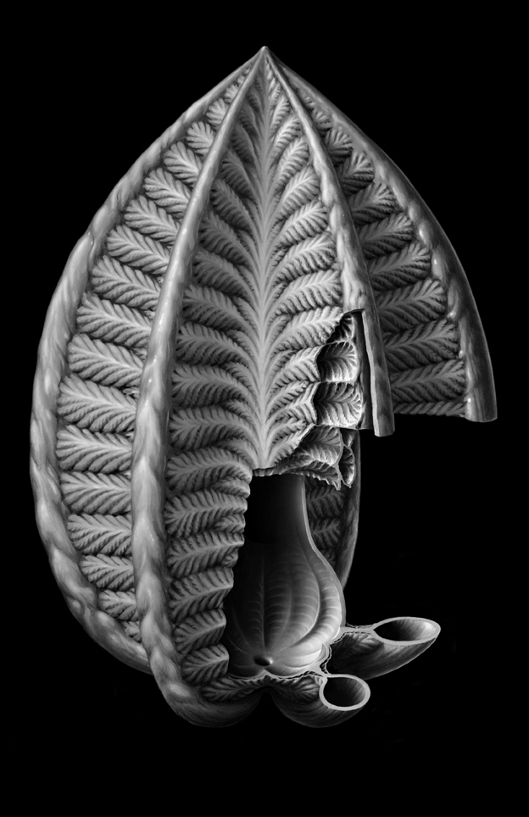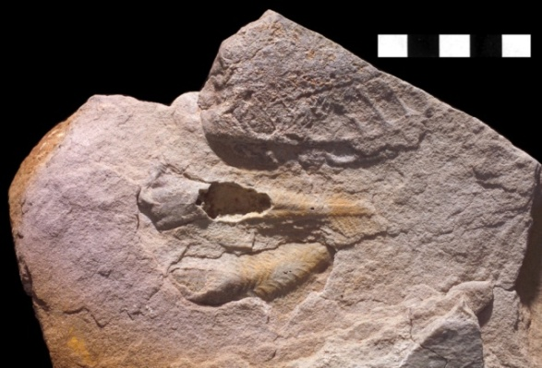

Fig. 2a. Peter Trusler’s reconstruction of Rangea. Fig. 2b. Three-dimensional specimen of Rangea discovered by participants in IGCP493, 587, 673.

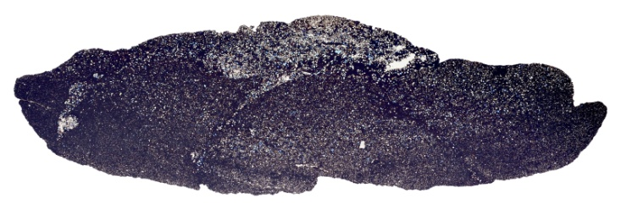

Fig. 3 3-d scans of two of more than 200+ specimens of Rangea discovered by participants in IGCP493, 587, 673, provided by a cooperative study funded by the Australian Synchrotron in Melbourne.

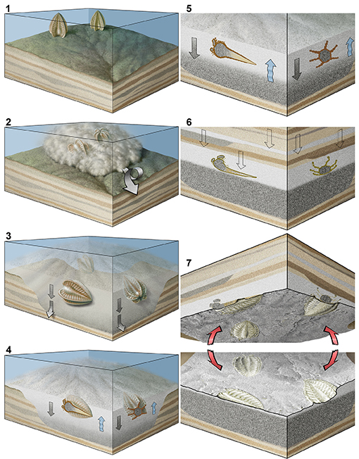

Fig. 4 Interpretation of life position and preservation of Rangea in the shallow, nearshore marine setting of the ancient Nama sea some 540 million years ago (art by Peter Trusler).

Members of another group of weird organisms nearly unique to the Nama Group sediments in southern Namibia are the erniettomorphs – Ernietta, Pteridinium, and Swartpuntia. Pteridinium simplex was first described by Gürich in 1933, and its body consisted of a double-layered palisade of tubes, an architecture quite distinct from the ‘fractal’ morphology of Rangea. Thus far, all most specimens of Pteridinium have been found in transported masses, and their lifestyle is still controversial, with some specimens reported to have been preserved in situ at the top of the Swartpunt section (Narbonne, 1997; Darroch et al., 2015). Traditional views (e.g. Jenkins, 1985) regarded them as fronds extending into the water column, but this was disputed by Seilacher (1989, 1992) and

Grazhdankin and Seilacher (2005), who regarded Pteridinium as mainly or completely infaunal. Subsequent discoveries of material preserved in massive downslope avalanches, again on farms in southern Namibia (Elliott et al., 2011; Meyer et al., 2014a, b) has challenged the infaunal lifestyle interpretation, and so just how these tubular organisms lived still remains a mystery.

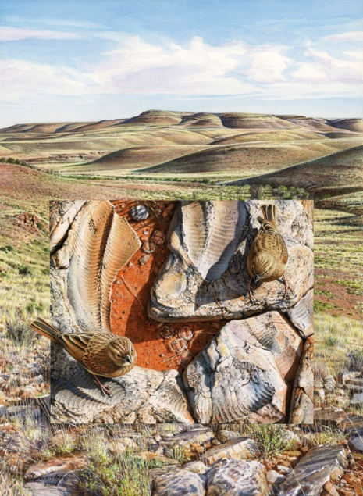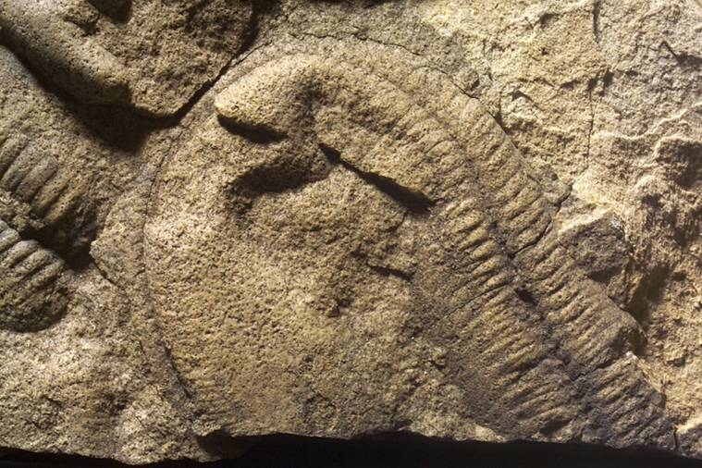

Fig. 5a A painting by palaeo-artist Peter Trusler of the Fig. 5b Pteridinium fossil from Aarhauser locality in southern Namibia, preserved Past and the present, illustrating a block in an avalanche mass flow which took place in and ancient ocean.
containing the ancient Ediacaran Pteridinium with the
modern landscape of where it was discovered in
Neoproterozoic rocks of Southern Namibia in the background.

Spectacular discoveries of the first ever truly complete specimens of Ernietta Pflug, 1966 were found by Andrey Ivantsov as part of a UNESCO International Geosciences Project in the early 2000’s. Ernietta seems to have been a bag-shaped organism, also constructed of the double-layered palisade of parallel tubes diagnostic of the Erniettomorpha. Before Andrey’s discovery, Ernietta was known from hundreds of specimens, most of them transported, and not in the place where they once lived (Elliott et al., 2016). All specimens until this discovery were also incomplete. But the new specimens were preserved at the base of small, near shore marine channels, and appear to have lived in close-knit colonies. Some were absolutely complete and consisted of a basal bag-shaped anchor, permanently buried in the sediment, with the more distal part extending upwards into the water column, consisting of two facing frondose structures at its distal opening (Ivantsov et al., 2015). Using a combination of field observations and computational fluid dynamics modeling, Gibson et al. (2019) recently illustrated that living gregariously in aggregated populations was almost certainly an ecological adaptation that aided in feeding; multiple individuals living together would have increased vertical mixing in the water column, helping to transport food particles to their neighbors downstream, much in the way that modern oysters and mussels do. San (Bushman) artists had long ago seen these fossils and left carved images in the rocks: could these have been the first to document the detail of the complete morphology or did these fossils on the neighboring rocks provide the graphic inspiration for other meanings?

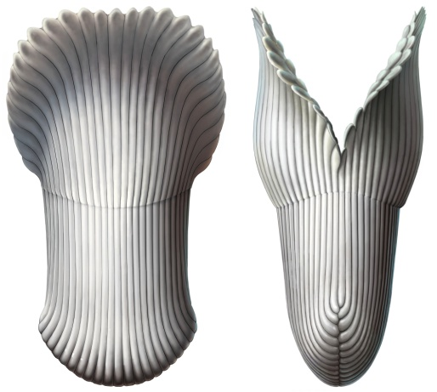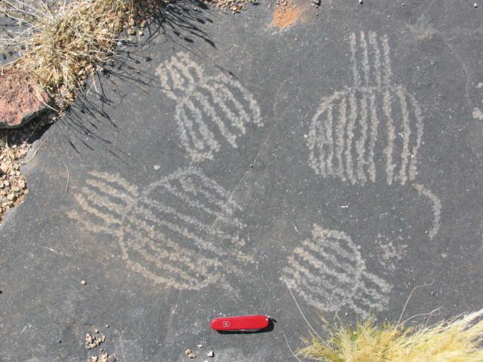

Fig. 6 Ernietta images. Two on the left are near complete specimens recovered by participants in UNESCO International Geoscience Programs 493 and 587, the middle spectacular one found by Andrey Ivantsov. The engravings on the right were made by San artists, long ago.

Yet another enigmatic fossil is Swartpuntia Narbonne et al. (1997). It was a multifoliate, frondose erniettomorph that reached over a decimeter in height. It is abundant at the top of Swartpunt where geochronological and geochemical data imply it lived during the last one million years of the Ediacaran Period, alongside Pteridinium. Other, rarer Ediacara-type impressions from Namibia include Protechiurus Glaessner, 1979 and Ausia Hahn and Pflug, 1985, most of these taxa based on one or a few specimens, and consequently of uncertain affinities. Carbonaceous tubular compression fossils such as Vendotaenia are locally common (Cohen et al., 2009).

Circular, cm-scale discs comprise another common taxon, and these invariably occur in profusion, completely covering bedding planes with adjoining specimens, all of them exactly the same size and presumably the result of a single spatfall. These fossils were originally named Hagenetta aarensis Hahn and Pflug, 1988 and were interpreted as bivalve shells, but Ivantsov et al. (2015) suggested that the name Beltanelliformis has priority over the other common names (e.g. Nemiana) that have previously been used for this taxon. Beltanelliformis (Nemiana) is abundant in shallow-water Ediacaran assemblages worldwide, and is most commonly interpreted as a spherical ‘polyp’ of unknown affinities (Narbonne and Hofmann, 1987) or as a Nostoc-like ball of bacteria (Ivantsov et al., 2015). Clearly, there is still a lot to sort out with respect to the true relationships of many of these early, multicellular, large organisms, and that is what makes further work on the fossils from the late Precambrian and early Phanerozoic in Namibia an exciting challenge.

Besides these megascopic, enigmatic organisms, another major contribution that the Namibian late Neoproterozoic fossil record continues to make to understanding the progress of life on Earth is the abundant occurrence of the world’s first skeletal fossils that are preserved in a number of carbonate rocks that occur throughout the Nama Group. Some of these early hard skeletoned forms, played a major role in building some of the world’s first skeletal-microbial reefs (Germs, 1972; Grant, 1990; Grotzinger et al., 2000, 2005; Wood et al., 2002; Wood, 2015; Penny et al., 2014; Zhuravlev et al., 2015). Cloudina Germs, 1972, the first pre-Cambrian shelly

fossil named anywhere in the world, consists as mm-scale diameter calcified tubes with a distinctive pattern of stacked, funnel-shaped transverse partitions inside the tube. Most researchers consider it likely that Cloudina was a true animal. Namacalathus (Grotzinger et al., 2000) is another calcified reef-dweller, which, like Cloudina, occurs as skeletal packstones between microbial elements in the reefs. Its structure is a cm-scale cup that sits atop a short stem, with a hole in the top of the cup and several holes along its sides. It also has been considered to be an animal, a metazoan that Zhuravlev et al. (2015) considered as a lophophorate, regarded by others as an ancestral lophophotrochozoan (Darroch, pers. Com., 2020).

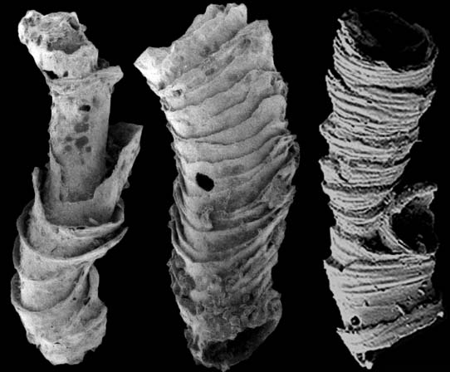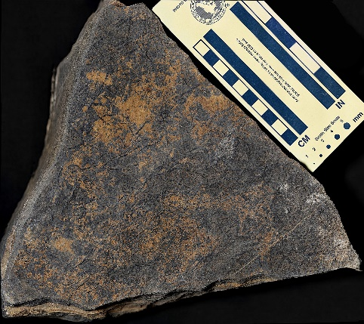

Fig 7 Cloudina, highly magnified on left and with scale on right. Specimen on right from southern Namibia.

The trigger of the earliest animal biomineralization, so well documented in in the Namibian record, has been proposed to be the ecological pressure from predation (Hua et al., 2003). However, more recent chemostratigraphic studies of the late Ediacaran strata in Namibia (Tostevin et al., 2019a), South China (Cui et al., 2016; Cui et al., 2019a; Cui et al., 2019b), Siberia (Wood et al., 2017), and Brazil (Caetano-Filho et al., 2019; Macedo Paula-Santos et al., 2019) reveal that the evolutionary novelty of animal biomineralization was probably environmentally triggered by enhanced chemical weathering and high seawater alkalinity at that time. Recent uranium isotope analyses of the Ediacaran-Cambrian strata in Namibia (Tostevin et al., 2019b) and South China (Wei et al., 2018; Zhang et al., 2018) suggest an expansion of anoxia in terminal Ediacaran oceans and dynamic marine redox fluctuations “across the line”, which may be the trigger for the demise of the Ediacarans and the rise of the Cambrian animals

An intriguing question is “what happened to the last of these first complex and large organisms that developed on Earth?” Recent analyses by Darroch et al. (2015; 2018) illustrate that the latest Ediacaran communities preserved in the Nama Group were relatively species-poor, and perhaps already in the throes of an extinction event. This decrease in the diversity of Ediacara biota worldwide coincides with both evidence for regional anoxia (e.g., Wood et al., 2015), and the rise of more complex Cambrian-type behaviors and ‘ecosystem engineering’, providing potential support for competing environmental and biological drivers of extinction, respectively. Only more data and new fossil discoveries will allow us to test between these two models, and determine what eventually led to the disappearance of the Ediacara biota ~538-539 million years ago. Intriguingly, a biological driver of extinction would raise uncomfortable parallels with the present day, where humans are altering our environment at a pace which threatens millions of species. In this fashion, this supposed ‘first mass extinction’ and end of the Ediacaran may offer clues and an invaluable lesson for interpreting the present biodiversity crisis. In the future, such knowledge will surely be of fundamental value in using our understanding of what happened to the Ediacarans and the dynamics of the dramatic biotic change at the beginning of the Cambrian.....and give much needed guidance on planning the future of humanity! How we use that understanding will most certainly be critical to our survival as a species. We just hope humanity listens!!!
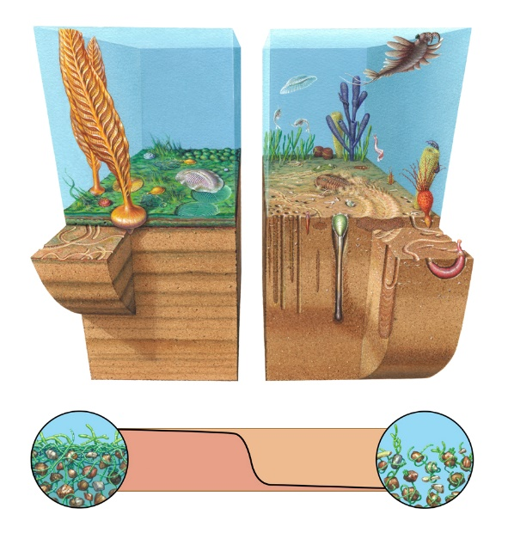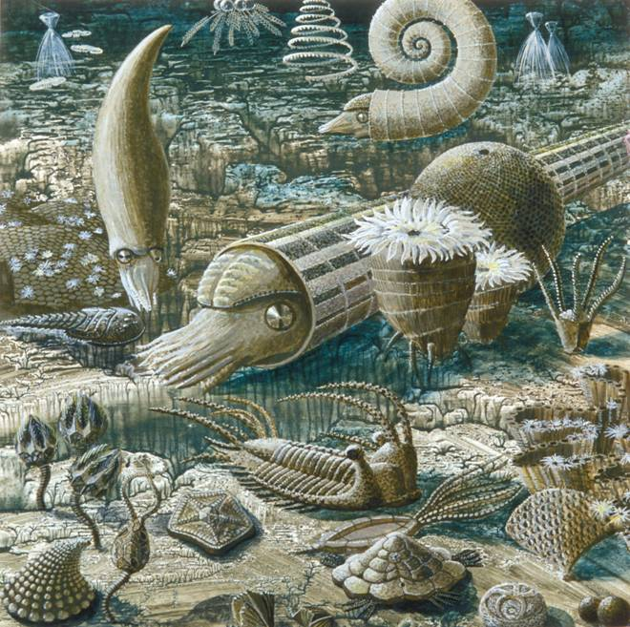

Fig. 8 The changes across the Precambrian-Cambrian Boundary – the crossing of a critical line for Life on Earth. On the left a biota dominated by the Ediacarans, which lacked burrowers, depended greatly on the massive microbial mats and chemistry of the surrounding ocean for nourishment. Most of the biota lacked eyes, guts, and few were able to move. All that changed when that Line was Crossed around 538-534 million years ago. The rocks, in Southern Namibia host many of the possible answers to just what happened at this time (art by Peter Trusler). On the right, life after that Line was Crossed, when the world began to seem familiar (courtesy of the Paleontological Institute, Moscow).

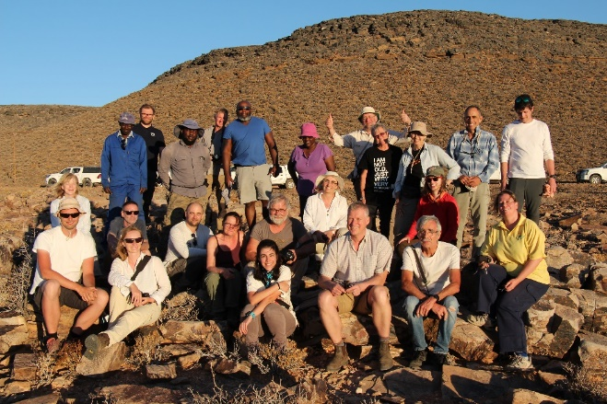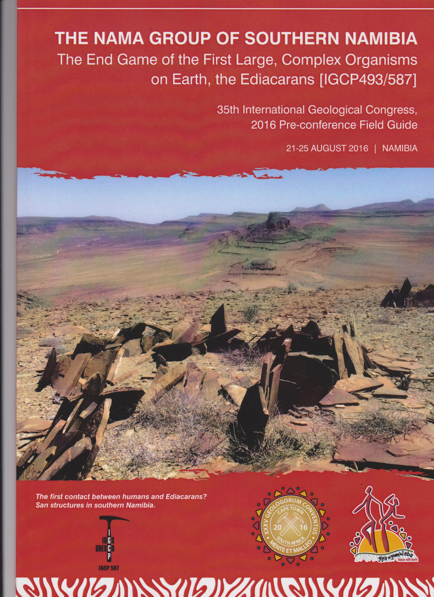

Fig. 9 IGCP673 field workshop (top) in March 2019, and IGCP587 field workshop held in 2016 prior to the 35th IGC conference, both in southern Namibia.

Useful References

Caetano-Filho, S., Macedo Paula-Santos, G., Guacaneme, C., Babinski, M., Bedoya-Rueda, C., Peloso, M., Amorim, K., Afonso, J., Kuchenbecker, M., Reis, H., Trindade, R.I.F., 2019. Sequence stratigraphy and chemostratigraphy of an Ediacaran-Cambrian foreland-related carbonate ramp (Bambuí Group, Brazil). Precambrian Research: 105365 https://doi.org/10.1016/j.precamres.2019.105365.

Cui, H., Kaufman, A.J., Xiao, S., Grazhdankin, D.V., Peek, S., Martin, A.J., Bykova, N.V., Rogov, V.I., Liu, X.-M., Zhang, F., Romaniello, S.J., Anbar, A.D., Peng, Y., Cai, Y., Schiffbauer, J.D., Meyer, M., Gilleaudeau, G.J., Plummer, R.E., Sievers, N.E., Goderis, S., Claeys, P., 2019a. Recent advances in understanding the terminal Ediacaran Earth-life system in South China and Arctic Siberia. Estudios Geológicos, 75: e097

Cui, H., Kaufman, A.J., Xiao, S., Peek, S., Cao, H., Min, X., Cai, Y., Siegel, Z., Liu, X.M., Peng, Y., Schiffbauer, J.D., Martin, A.J., 2016. Environmental context for the terminal Ediacaran biomineralization of animals. Geobiology, 14: 344–363 https://doi.org/10.1111/gbi.12178.

Cui, H., Xiao, S., Cai, Y., Peek, S., Plummer, R.E., Kaufman, A.J., 2019b. Sedimentology and chemostratigraphy of the terminal Ediacaran Dengying Formation at the Gaojiashan section, South China. Geological Magazine, 156: 1924–1948 https://doi.org/10.1017/S0016756819000293.

Darroch, SAF., Sperling, E.A., Boag, T., Racicot, R.A., Mason, S.J., Morgan, A.S., Tweedt, S., Myrow, P., Erwin, D.H. and Laflamme, M. 2015. Biotic replacement and mass extinction of the Ediacara biota. Proceedings of the Royal Society, B, 282.

Darroch, S.A.F., Smith, E., Laflamme, M., and Erwin, D.H. Ediacaran extinction and Cambrian Explosion. 2018. Trends in Ecology and Evolution, 33, 653-663.

Dzik, J., 2002. Possible Ctenophoran affinities of the Precambrian “seapen” Rangea. Journal of Morphology, 252, 315-334.

Elliott, D.A., Vickers-Rich, P., Trusler, P., and Hall, M., 2011. New evidence on the taphonomic context of the Ediacaran Pteridinium. Palaeontologica Polonica, 56 (3): 641-650.

Elliott, D. A., Trusler, P., Narbonne, G., Vickers-Rich, P., Hoffmann, K. H. & Schneider, G. I. C., in 2016. Ernietta from the Late Ediacaran Nama Group, Namibia. Journal of Paleontology.

Erwin, D.H., Laflamme, M., Tweedt, S. M., Sperling, E. A., Pisani, D. and Peterson, K. J., 2011. The Cambrian conundrum: Early Divergence and later ecological success in the Early History of Animals. Science, 334: 1091-1097.

Ford, T., 1958. Precambrian fossils from Charnwood Forest. Proceedings of the Yorkshire Geological Society, 31: 211-217.

Gehling, J. G. and Narbonne, G. M., 2007. Spindle-shaped fossils from the Mistaken Point assemblage, Avalon Zone, Newfoundland. Canadian Journal of Earth Sciences, 44: 367-387.

Germs, G. J. B., 1972. New shelly fossils from Nama Group south West Africa, 1972. American Journal of Science, 272: 752-761.

Geyer, G. 2005. The Fish River Subgroup in Namibia: Stratigraphy, depositional environments and Proterozoic-Cambrian boundary problem revisited. Geological Magazine, 142 (5): 465-598.

Geyer, G., Linnemann, U., Vickers-Rich, P., Gartner, A., Ovtcharova, M., Hofmann, M. & Zieger, J. (2019, in advanced preparation). The Ediacaran-Cambrian boundary interval revisited: An updated record of the Swartpunt section (Nama Supergroup, Namibia) and its significance for the Ediacaran-Cambrian biostratigraphy and faunal turnover.

Glaessner, M. F., 1979. An echiruid worm from the Late Precambrian. Lethaia, 12: 121-124.

Grant, S. W. F., 1990. Shell, structure and distribution of Cloudina, a potential index fossil for the terminal Proterozoic. American Journal of Science, 290-A: 261-294.

Grazdankin, D. and Seilacher, A., 2005. A re-examination of the Nama type Vendian organism Rangea schneiderhoehni. Geological Magazine, 142: 571-582.

Grotzinger, J. P., Adams, E. W., Schröder, S., 2005. Microbial–metazoan reefs of the terminal Proterozoic N Nama Group (c. 550–543 Ma), Namibia. Geological Magazine 142: 499– 517.

Grotzinger, J. P., Watters, W. A. and Knoll, A. H., 2000. Calcified metazoans in thrombolite-stromatolite reefs of the terminal Proterozoic Nama Group, Namibia. Paleobiology, 26 (3): 334-359.

Gürich, G., 1930. Die Bislang Altesten Spuren von Organismen in Südafrika. Compte Rendu XV International Geological Congress, 2, Palaeontologische Zeitschrift, Section VII: 670-681.

Gürich, G., 1933. Die Kuibis-Fossilien der Nama Formation von Sudwestafrika. Palaeontogische Zeitschrift 15: 137-154.

Hahn, G. and Pflug, H. D., 1985. Polypenartige Organismen aus dem Jung-Prakambrium (Nama-Gruppe) von Namibia. Geologica et Palaeontologica, 19: 1-13.

Hahn, G. and Pflug, H. D., 1988. Zweischalige Organismen aus dem Jun- Präkambrium (Vendium) von Namibia (SW-Afrika). Geologica et Palaeontologica, 22: 1-19

Hall, M., Kaufman, A. J., Vickers-Rich, P., Ivantsov, A., Trusler, P., Linnemann, U., Hofmann, M., Elliott, D., Cui, H., Fedonkin, M. A., Hoffmann, K.H., Wilson, S. A., Schneider, G. and Smith, J., 2013. Stratigraphy, palaeontology and geochemistry of the late Neoproterozoic Aar Member, southwest Namibia: Reflecting environmental controls on Ediacara fossil preservation during the terminal Proterozoic in African Gondwana. Precambrian Research, 238: 214-232.

Hua, H., Pratt, B.R., Zhang, L.-Y., 2003. Borings in Cloudina shells: complex predator-prey dynamics in the terminal Neoproterozoic. PALAIOS, 18(4-5): 454–459 https://doi.org/10.1669/0883-1351(2003)018<0454:bicscp>2.0.co;2.

Ivantsov, A. Yu., Narbonne, G. M., Trusler, P. W., Greentree, C. and Vickers- Rich, P., 2015. Elucidating Ernietta: new insights from exception specimens in the Ediacaran of Namibia. Lethaia, DOI:10.1111/let.12164: 1-15.

Ivantsov, A. Yu., Vickers-Rich, P., Zakrevskaya, M. A. and Hall, M., 2020, in press. Conical thecae of Precambrian macroorganisms. Paleontological Zhurnal: 1-9, plus figures.

Jenkins, R. J. F., 1985. The enigmatic Ediacaran (Late Precambrian) genus Rangea and related forms. Paleobiology, 11 (3): 336-355.

Jenkins, R. J. F., 1992. Functional and ecological aspects of Ediacaran assemblages. In: Lipps, J. H. and Signor, P. W. Origin and Early Evolution of the Metazoa, Plenum Press, New York: 131-176.

Laflamme, M. and Narbonne, G., 2008. Ediacaran fronds. Palaeogeography, Palaeoclimatology, Palaeoeconogy, 258: 162-179.

Laflamme, M., Darroch, S.A.F., Tweedt, S., Peterson, K.J., Erwin, D.H. 2013. The end of the Ediacara biota: extinction, biotic replacement, or Cheshire cat? Gondwana Research, 23: 558-573.

Linnemann U, Ovtcharova M, Schaltegger U, Gärtner, A., Hautmann, M. Geyer, G., Vickers-Rich, P., Rich, T., Plessen, B., Hofmann, M., Zieger, J., Krause, R., Kiesfeld, L., Smith, J., 2019. New high‐resolution age data from the Ediacaran–Cambrian boundary indicate rapid, ecologically driven onset of the Cambrian explosion. Terra Nova, 1–10; 31: 49-58.

Linnemann, U., Vickers-Rich, P., Ovcharova, M., Gartner, A., Hofmann, M. &amp; Zieger, J., 2019. Field Workshop. Precambrian-Cambrian Boundary, Ediacara Biota, Snowball Earth deposits, and the Geology of the Nama Basin around Aus (Southern Namibia). March 4, 2019 to March, 12, 2019. 18pp + Appendix of 11 Research Publications.

Macedo Paula-Santos, G., Caetano-Filho, S., Enzweiler, J., Navarro, M.S., Babinski, M., Guacaneme, C., Kuchenbecker, M., Reis, H., Trindade, R.I.F., 2019. Rare earth elements in the terminal Ediacaran Bambuí Group carbonate rocks (Brazil): evidence for high seawater alkalinity during rise of early animals. Precambrian Research, 336: 105506 https://doi.org/10.1016/j.precamres.2019.105506.

Meyer et al., 2014 a. Taphonomy of the Ediacaaran fossil Pteridinium simplex preserved three-dimensionally in mass flow deposits, Nama Group, Namibia. Journal of Paleontology, 88 (2): 1-12.

Meyer et al., 2014b. Three-dimensional microCT analysis of the Ediacara fossil Pteridinium simplex sheds new light on its ecology and phylogenetic affinity.

Narbonne, G. M., 2004. Modular construction of early Ediacaran complex life forms. Science, 305: 1141-1144.

Narbonne, G. M., Saylor, B. Z. and Grotzinger, J. P., 1997. The youngest Ediacaran-fossils from southern Africa. Journal of Paleontology, 71: 953-967.

Ovtcharova, M., Messori, F., Linnemann, U., Hofmann, M., Zieger, J., Geyer, G.,Vickers-Rich, P., Soldatenko, Y. &amp; Albani, A. El., 2019. submitted). Detailed Ediacaran timeline for White Sea and Nama fossil assemblages (Namibia and Ukraine). Goldschmidt2019.

Penny, A. M., Wood, R., Curtis, A., Bowyer, F., Tostevin, R. And K.-H. Hoffman, 2014. Ediacaran metazoan reefs from the Nama Group, Namibia. Science, 344 (6191): 1504-1506.

Pflug, H.D., 1966. Neue Fossilreste aus den Nama-Schichten in Sudwest- Afrika. Palaontologische Zeitschrift, 40: 14-25.

Pflug, H. D., 1970a. Zur fauna der Nama-Schichten in Sudwest-Afrika. I. Pteridinia, bau und systematische zugenhorigkeit. Palaeontographica Abteilung A, 134: 226-262.

Pflug, H. D., 1970b. Zur fauna der Nama-Schichten in Sudwest-Afrika. II. Rangeidae, bau und systematische Zugehorigkeit. Palaeontographica139: 134-170.

Pflug, H. d., 1972. Zur fauna der Nama-Schichten in Sudwest-Afrika. III.Erniettomorpha, bau und systematic. Palaeontolgraphica Abteilung A, 135: 198-231

Richter, R., 1955. Die altesten Fossilien Sud-Afrikas. Senckenberrt, Lethaia, 36 (3/4): 243-289.

Seilacher, A., 1989. Vendozoa. Organismic construction in the Proterozoic biosphere. Lethaia, 22: 229-239.

Seilacher, A., 1992. Vendobionta and Psammocorallia: Lost constructions of Precambrian evolution. Journal of the Geological Society, London, 149: 607-613.

Seilacher, A. and Gishlick, A. D. 2014. Vendobionts: Lost life forms of Ediacaran times. In Morphodynamics, 9, CRC Press: 133-148.

Sharp, A. C., Evans, A. R., Wilson, S. A. and Vickers-Rich, P., 2017. First non-destructive internal imaging of Rangea, an icon of complex Ediacaran life. Precambrian Research, 299 (September 2017): 303-308.

Sprigg, R. G., 1947. Early Cambrian (?) jellyfishes from the Flinders Ranges, South Australia. Transactions of the Royal Society of South Australia, 71 (2): 212-224.

Tostevin, R., Bradbury, H.J., Shields, G.A., Wood, R.A., Bowyer, F., Penny, A.M., Turchyn, A.V., 2019a. Calcium isotopes as a record of the marine calcium cycle versus carbonate diagenesis during the late Ediacaran. Chemical Geology, 529: 119319 https://doi.org/10.1016/j.chemgeo.2019.119319.

Tostevin, R., Clarkson, M.O., Gangl, S., Shields, G.A., Wood, R.A., Bowyer, F., Penny, A.M., Stirling, C.H., 2019b. Uranium isotope evidence for an expansion of anoxia in terminal Ediacaran oceans. Earth and Planetary Science Letters, 506: 104–112 https://doi.org/https://doi.org/10.1016/j.epsl.2018.10.045

Vickers-Rich, P., Ivantsov, A. Yu., Trusler, P. W., Narbonne, G., Hall, M., Wilson, S. A., Greentree, C. Fedonkin, M. A., Elliott, D. A., Hoffmann, K. H. and Schneider, G. I. C., 2013. Reconstructing Rangea: New discoveries from the Ediacaran of Southern Namibia. Journal of Paleontology, 87 (1): 1-15.

Vickers-Rich, P., Narbonne, G., Laflamme, M., Darroch, S., Kaufman, A. J. and Kriesfeld, L. et al., 2016. The Nama Group of Southern Namibia. Field Guide for Workshop of the 35th International Geological Congress, 21-25 August 2016. New Artworx in cooperation with the 35th International Geological Congress Committee, Melbourne: 77 pp.

Vickers-Rich, P. and P. Komarower, eds., 2007. The Rise and Fall of the Ediacaran biota. Geological Society of London Special Publication, 286: 456 pp.

Wei, G.-Y., Planavsky, N.J., Tarhan, L.G., Chen, X., Wei, W., Li, D., Ling, H.-F., 2018. Marine redox fluctuation as a potential trigger for the Cambrian explosion. Geology, 46: 587–590 https://doi.org/10.1130/G40150.1.

Wood, R. A., Grotzinger, J. P. and Dickson, J. A. D., 2002. Proterozoic modular biomineralised Metazoan from the Nama Group, Namibia. Science, 296: 2383-2386.

Wood, R., Ivantsov, A.Y., Zhuravlev, A.Y., 2017. First macrobiota biomineralization was environmentally triggered. Proceedings of the Royal Society B: Biological Sciences, 284(1851): 20170059 https://doi.org/10.1098/rspb.2017.0059

Wood, R. A. Poulton, S. W., Prave, A. R., Hoffmann, K.-H., Clarkson, M. O., Guilbaud, R., Lyne, J. W., Tostevin, R., Bowyer, F., Penny, A. M., Curtis, A. and. Kasemann, S. A.., 2015. Dynamic redox conditions control late Ediacaran metazoan ecosystems in the Nama Group, Namibia. Precambrian Research, 261: 252-271.

Xiao, S. and Laflamme, M., 2009. On the eve of animal radiation: Phylogeny, ecology and evolution of the Ediacara biota. Trends in
Ecology & Evolution, 24: 31-40.

Zhang, F., Xiao, S., Kendall, B., Romaniello, S.J., Cui, H., Meyer, M., Gilleaudeau, G.J., Kaufman, A.J., Anbar, A.D., 2018. Extensive marine anoxia during the termina Ediacaran Period. Science Advances, 4(6): eaan8983 https://doi.org/10.1126/sciadv.aan8983.

Zhuravlev, A., Yu, Wood, R.A. and Penny, A.M., 2015. Ediacaran skeletal metazoan interpreted as a lophophorate. Proceedings of the Royal Society B (Biological Sciences), 282: 20151860

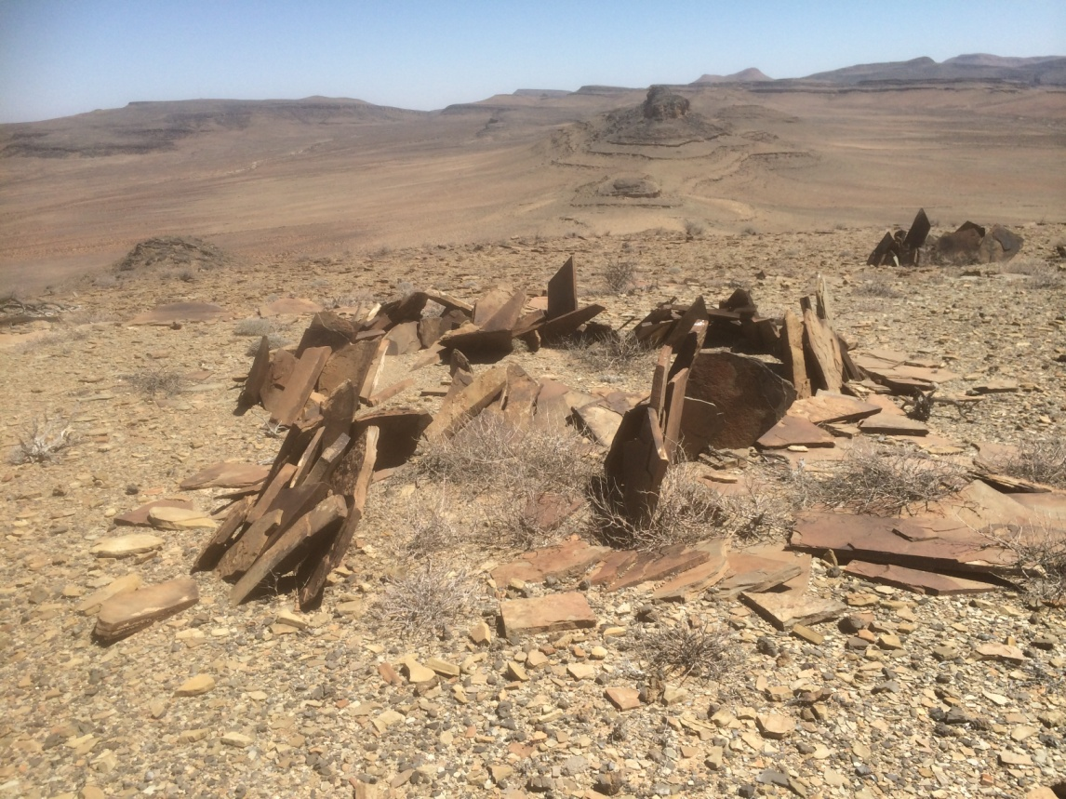

Fig. 10 Swartpunt in the distance – the “avenue” where the last vestiges of the SuperEon biota, the Ediacarans, are replaced by the Modern World of the Cambrian (the Phanerozoic) – where the Line is Crossed – in Southern Namibia.

23-1-2020 (330pm) (with comments from Mhopenji, Cui, Darroch, Laframme, Rich, Linnemann, Trusler, Swinkels, Narbonne, Ivantsov, Hofmann)

