

-
ACADEMIC PROGRAMS AND GOVERNANCE
STANDARD WORDING SUGGESTIONS
for Course Proposals

Academic Course Information Tab in Courseloop

Below are examples of standard wording that can be used to complete some of the fields in the Academic Course Information tab in Courseloop.
Course Type Description

Undergraduate certificates - Undergraduate certificates

Diplomas
- Pathway diploma - A non-award program, providing a pathway to designated Comprehensive or Specialist Bachelors courses (leading to awards at AQF7 or AQF8)
- Complementary study diploma - Complementary Study Diploma

Bachelor degrees
- Comprehensive courses: AQF 7 Comprehensive
- Specialist courses: AQF 7 Specialist

Bachelor honours degrees
- One-year honours courses: AQF 8 - 1yr Honours
- Specialist bachelor honours courses: AQF 8 Specialist
- Bachelor advanced honours courses AQF 8 Specialist

Graduate certificates and graduate diplomas
- Graduate certificates: AQF 8 Graduate Certificate
- Graduate diploma: AQF 8 Graduate Diploma

Postgraduate diplomas
Postgraduate certificates and postgraduate diplomas are not awards listed within the AQF. However, they are recognised in Malaysia and other countries in which Monash offers courses and it may be appropriate to offer courses leading to these awards in these countries.

- Postgraduate Certificate: Malaysian Qualification Framework Level 7 - PG Certificate
- Postgraduate Diploma: Malaysian Qualification Framework Level 7 - PG Diploma

Master's degrees
- Expert master’s: AQF 9 Expert
- Professional entry master's: AQF9 Professional
  - Note: for master’s degrees with a volume of learning of 144 to 192 credit points you are required to include (extended) at the end, e.g.:
AQF9 Professional (extended)

Double degree courses
- Horizontal double: add the course type of each single degree including the title of each course, e.g.: AQF8 Specialist - Bachelor of xxxx and AQF7 Comprehensive - Bachelor of xxxx
- Vertical double: add only the course type of each single degree, e.g.: AQF7 Specialist and AQF9 Expert

Exit only awards
- UG exit only - UG exit only
- PG exit only - PG exit only
Total Credit Points

UG course full-time only:

Graduate Certificate part-time only:

Master’s full-time and part-time with 3 entry points:

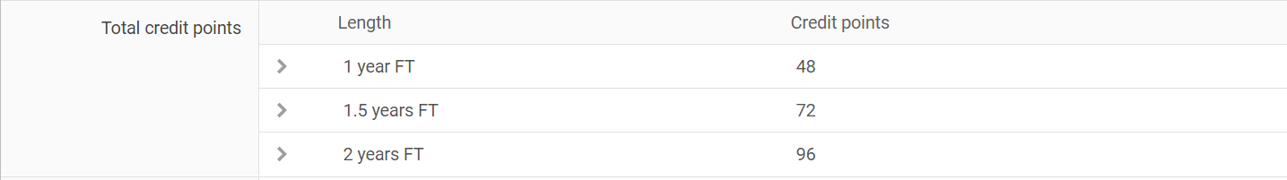

Master’s part-time offered through OES with 3 entry points:

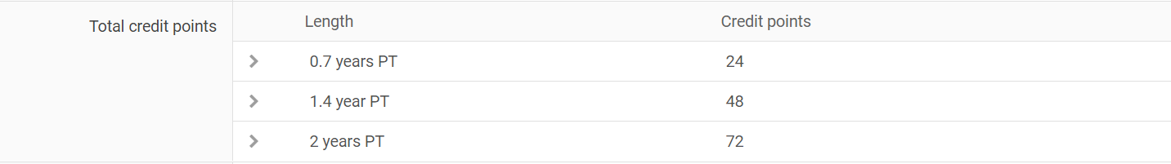

Standard part time duration

If the course is offered in full-time and part-time mode, the number of years to be included in this section should be the equivalent in part-time years (FT course duration x 2 years) of the highest full-time length that was entered under total credit points. But if the course is offered in part-time mode only, the number of years to be included in this section should match the highest length that was entered under total credit points.

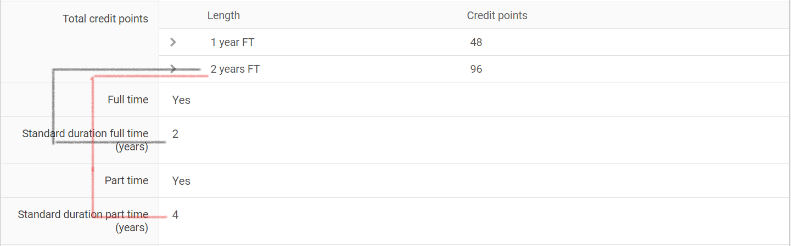

Examples of part-time years equivalencies are listed below:

Australia, Malaysia, SEU and Indonesia courses | OES Courses*  *these courses are only offered in PT mode.
UG  3 years = 6  4 years = 8  PG  2 years = 4  1.5 years = 3  1 year = 2 | PG  72pts = 2  48pts = 1.4  24pts = 0.7

Maximum duration

The maximum time a student is allowed to complete a course is determined by the following formula: maximum course duration = full-time study course duration x 2 + 2 years. A faculty may determine a lower time limit for the maximum course duration if required, but if it is less than full-time study course duration x 2 years, Education Committee approval is required.

Examples of maximum duration equivalencies are listed below:

On Campus courses | OES Courses
Undergraduate  1 year = 4  3 years = 8  4 years = 10  5 years = 12  Postgraduate  2 years = 6  1.5 years = 5  1 year = 4  0.5 year = 3 | Postgraduate  72pts = 5  48pts = 4  24pts = 3

Course duration notes

On Campus courses | OES Courses
Undergraduate examples:  You have a maximum of 8 years to complete this course.  You have a maximum of 10 years to complete this course including any periods of intermission and suspension, and must be continuously enrolled throughout. | This course is taken in accelerated part-time duration due to the online carousel model of delivery. Students normally complete one unit per online teaching period over six teaching periods, but if you have relevant entry qualifications you may receive credit and be able to complete earlier.
Postgraduate Courses
This course normally takes 2 years full-time to complete but if you have relevant entry qualifications you may receive credit and be able to complete the course in 1.5 years or 1 year full-time, or part-time equivalent. You have a maximum of 6 years to complete this course including any periods of intermission and suspension, and must be continuously enrolled throughout.

Course offering note

For courses offered online through Monash - the mode of delivery should be off-campus and the note should read:

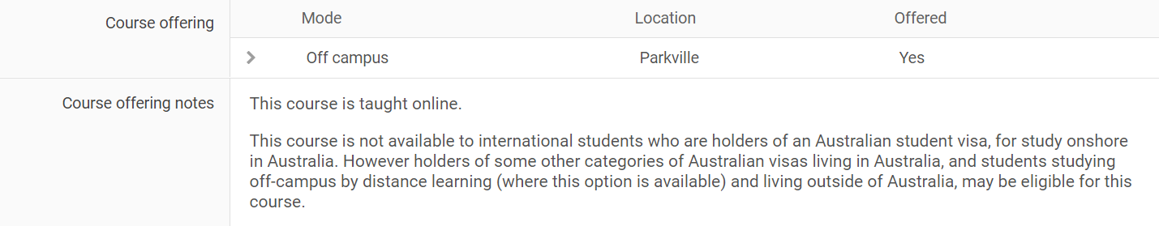

For courses offered online through OES - the mode of delivery should be online and the note should read:
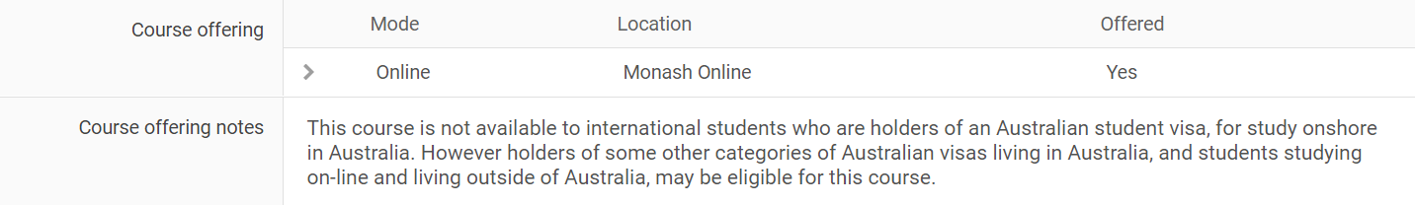

For courses where students may be required to travel between locations to undertake units:

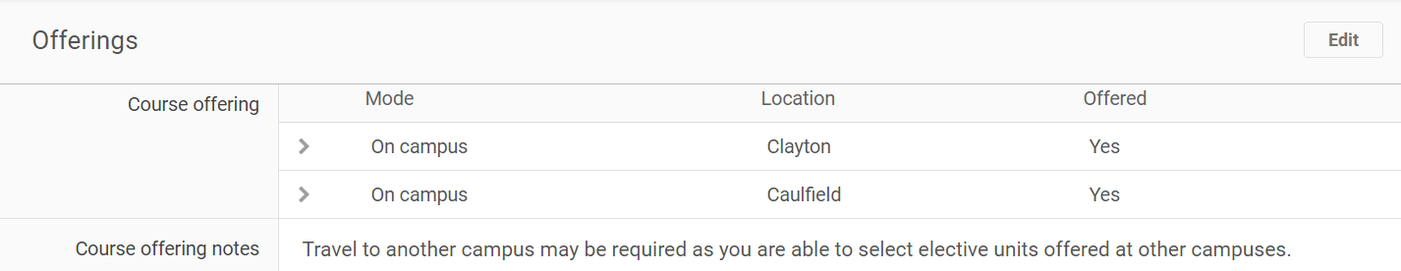

For courses where the main location is changing:

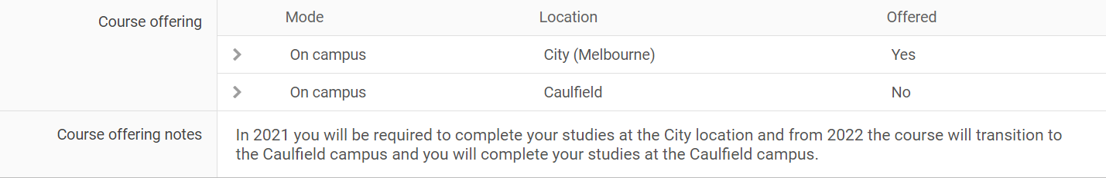

English language

Monash minimum: Level A, that is: IELTS (Academic): 6.5 overall (no band lower than 6.0); or Pearson Test of English (Academic): score of 58 overall with no band lower than 50; or TOEFL Internet-based test: score of 79 overall with minimum scores: Writing: 21, Listening: 12, Reading: 13 and Speaking: 18; or Equivalent approved English test

Monash minimum: Level B, that is: IELTS (Academic): 6.5 (with individual band scores of Writing: 6.0, Listening: 6.5, Reading: 6.5 and Speaking: 6.0); or Pearson Test of English (Academic): score of 58 overall with minimum scores: Writing 50, Listening 58, Reading 58, Speaking 50; or TOEFL Internet-based test: score of 79 overall with minimum scores: Writing 21, Listening 20, Reading 19, Speaking 18; or Equivalent approved English test

Monash minimum: Level C, that is: IELTS (Academic): 7.0 overall (no band lower than 6.5); or Pearson Test of English (Academic): score of 65 overall with no band lower than 58; or TOEFL Internet-based test: score of 94 overall with minimum scores: Writing: 24, Listening: 20, Reading: 19 and Speaking: 20; or Equivalent approved English test

Monash minimum: Level D, that is: IELTS (Academic): 7.0 overall (no band lower than 7.0); or Pearson Test of English (Academic): score of 65 overall with no band lower than 65; or TOEFL Internet-based test: score 98 overall with minimum scores: Writing: 27, Listening: 24, Reading: 24 and Speaking: 23; or Equivalent approved English test

Monash minimum: Level E, that is: IELTS (Academic): 7.0 overall with Listening: 7.5, Reading: 7.0, Writing 7.0, Speaking 7.5; or Pearson Test of English (Academic): score of 65 overall with minimum scores: Writing 65, Listening 73, Reading 65, Speaking 73; or TOEFL internet-based test: score of 102 overall with Listening: 27, Reading: 24, Writing: 27, Speaking: 24; or Equivalent approved English test

Minimum entry requirements

Undergraduate courses:

Each section must start with the words: “Monash minimum: Level…”, and be followed by the corresponding VCE/IB statements outlined in the table below:

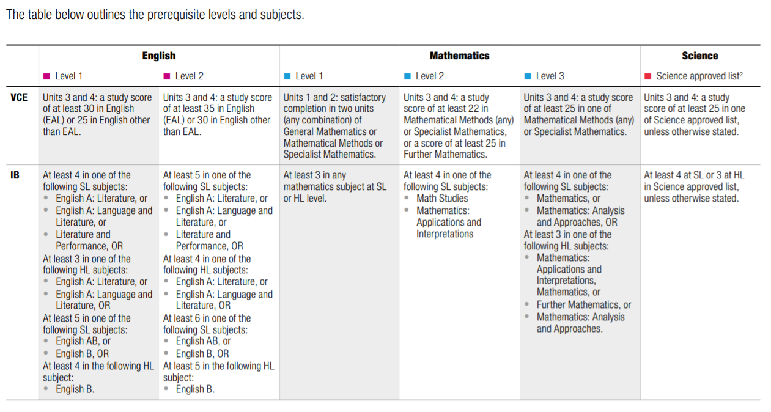

VTAC subject bonus:

Example from Bachelor of Science and Bachelor of Arts:
A study score of 25 in two but no more than four of Biology, Chemistry, Environmental Science, Geography, Maths: Mathematical Methods (any), Maths: Specialist Mathematics, Physics or Psychology equals 2 aggregate points per study. A study score of 30 in one but no more than one of Biology, Chemistry, Environmental Science, Geography, Maths: Mathematical Methods (any), Maths: Specialist Mathematics, Physics or Psychology equals 2 aggregate points per study.

A study score of 25 in one but no more than four of Classical Studies, any History, Literature, any LOTE, Australian Politics or Global Politics equals 2 aggregate points per study. Overall maximum of 8 points.

Non-year 12 entry

The suggested structure is as follows:
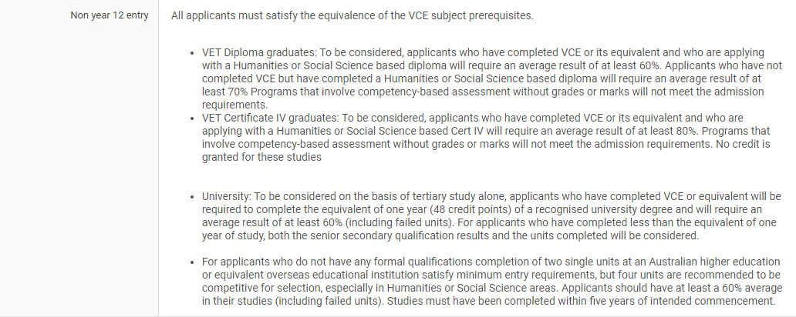

Postgraduate courses:

The preferred wording to be used should follow the suggested order below. Please note that some elements may not be required.

[An Australian minimum qualification level required]
+
[discipline e.g. cognate or not cognate]
+
[minimum achievement level e.g. credit average / WAM / GPA]
+
[additional requirements e.g. work experience]

For example:

- An Australian bachelor degree or equivalent qualification
- An Australian bachelor degree (or equivalent) in Nursing with at least a credit (60%) average.
- An Australian bachelor degree (or equivalent) with a weighted Average Mark (WAM) of 60, plus two years relevant work experience.

If the course has multiple entry levels, the minimum entry requirements for each level should follow the suggested order. Each entry point must identify the entry level, the number of credit points to be completed by students and the duration for both full-time and part-time offerings. For example:
Entry level 1 96 points to complete Duration: 2 years full-time, 4 years part-time
An Australian bachelor degree (or equivalent) with at least credit (60%) average, or equivalent qualification and experience approved by the faculty.

Entry level 2 72 points to complete Duration: 1.5 years full-time, 3 years part-time
An Australian bachelor degree (or equivalent) in a cognate discipline including humanities or social sciences with at least credit (60%) average, or equivalent qualification and experience approved by the faculty.
or
An Australian bachelor degree (or equivalent) and an Australian graduate certificate (or equivalent) in a cognate discipline including humanities or social sciences with at least pass (50%) average in both qualifications, or equivalent qualification and experience approved by the faculty.

Entry level 3 48 points to complete Duration: 1 years full-time, 2 years part-time
An Australian bachelor honours degree (or equivalent) in a cognate discipline including humanities or social sciences with at least credit (60%) average, or equivalent qualification and experience approved by the faculty.

Note: faculties interested in admitting students based on equivalent qualification and experience should use the text highlighted in yellow. This is the standard wording approved.

Double degrees:

The suggested structure for this field is as follows:

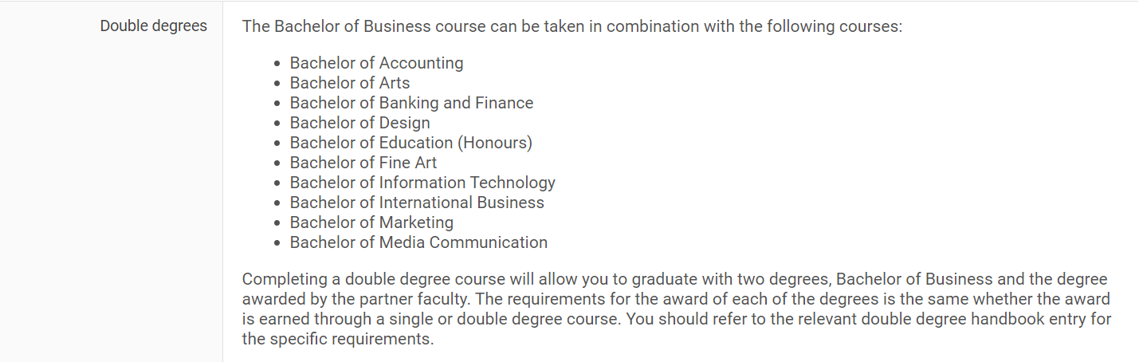

Specialisations:

The suggested structure for this field is as follows:

The information within an areas of study follows a similar structure to that of a course, but please note the following additional points:
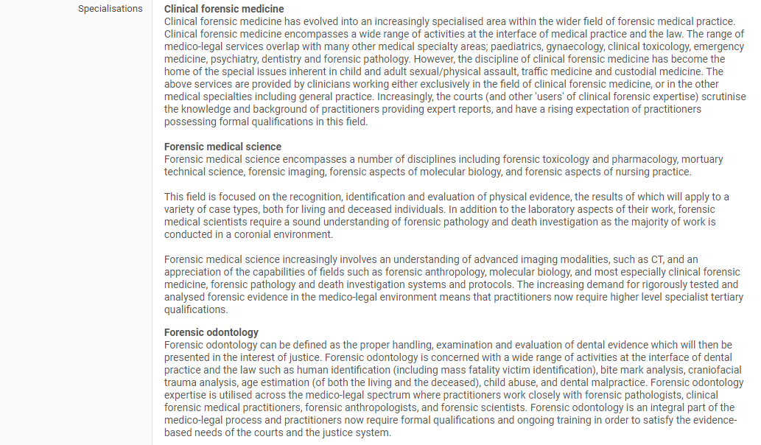

Areas of study

Description:

It is important to include an availability statement under this field to inform students of the following:

- course(s) the Area of Study is offered in,
- location(s) where the area of study is taught, and
- whether it is offered as a minor, major, extended major, undergraduate or post graduate specialisation, etc.

For example:



Learning outcome information for area of study section:

In addition to achieving the broad outcomes of your course, and successfully completing this area of study you will be able to:
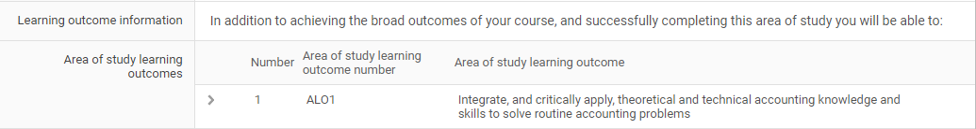

Course structure

Information on the structure and design of different course types is available at:

UG comprehensive courses (see Course Design Procedures 3.9)
- Always comprises three equal parts:
- course specified
- course grouped major, and
- free electives

UG specialist courses (see Course Design Procedures 3.10)
- Describes the themes that come together in professional practice.

Professional entry masters courses
- Describes the themes that come together in professional practice.

Expert Masters courses (see Course Design Procedures 3.25)
- Describes the parts that a student needs to complete depending on the entry level).

The course structure section should also include links to course progression maps, and for Master courses with multiple entry points an explanation of the specific course structure per entry level.

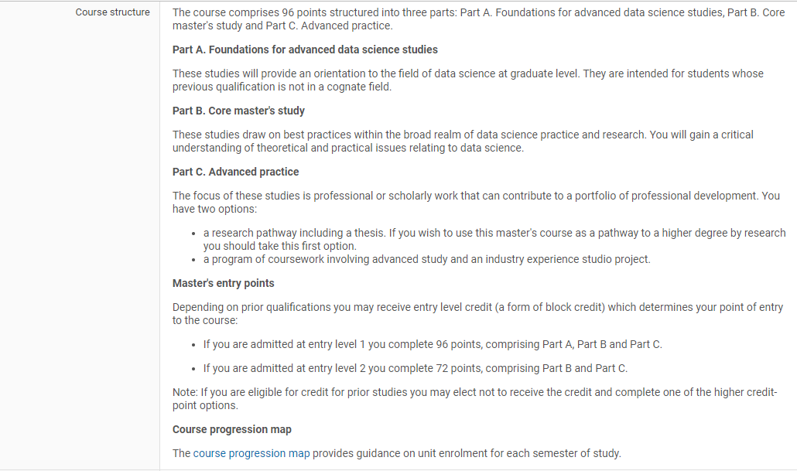

Learning outcome information

This section must always include two statements:
- the first one explains that course learning outcomes are aligned with the AQF level of the course and Monash Graduate Attributes;
- the second, introduces the course learning outcomes.

For example:

Course requirements

The following information should be included:
A statement that list the parts with their respective credit point requirements:

- This course comprises 144 points, of which 96 points must be from computer science study and 48 points are used to provide additional depth or breadth through elective study.

- The course develops through theme studies in: Part A. Foundational computer science study (42 points), Part B. Professional skills study (6 points), Part C. Specialist discipline knowledge and Part D. Problem solving and analytical skills (36 points), Part E. Applied practice (12 points), and Part F. Free elective study (48 points).
- Specific course rules

  - In choosing your units, you must ensure that you complete no more than 10 units (60 points) at level 1 and at least six units (36 points) at level 3, including four units (24 points) at level 3 offered by the Faculty of Business and Economics.

- A statement indicating the credit point of the majority of units in the course.

  - Units are 6 points unless otherwise stated.
- The course requirements: unit codes and titles divided by Part or Theme.

For example:
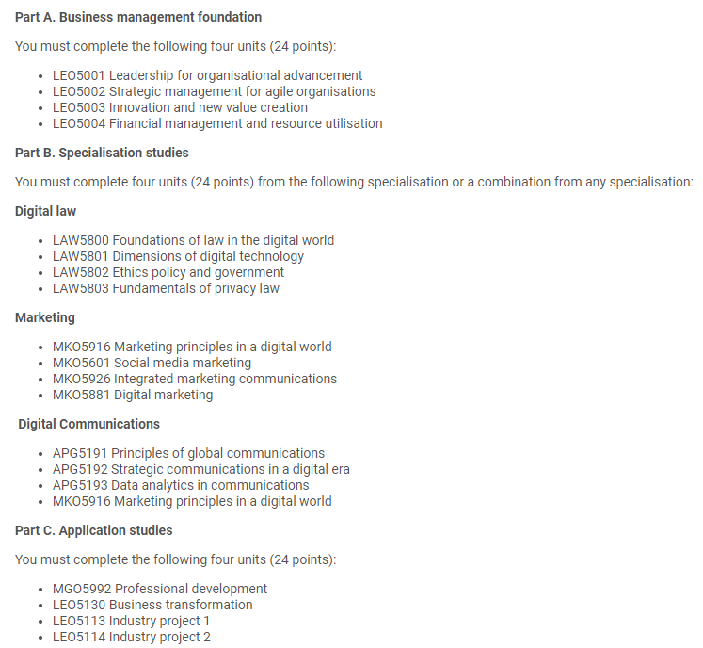

Alternative exits

This section should include the course title and the specific course requirements that a student must achieve in order to receive the alternative exit award.

The standard wording is:

Undergraduate double degree example:

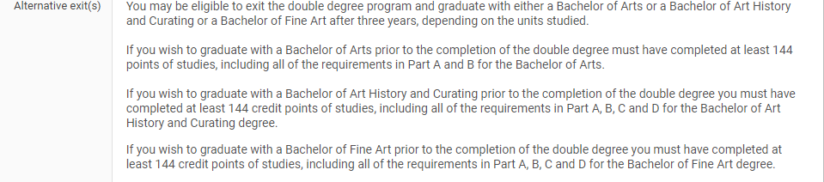

Postgraduate double degree example:

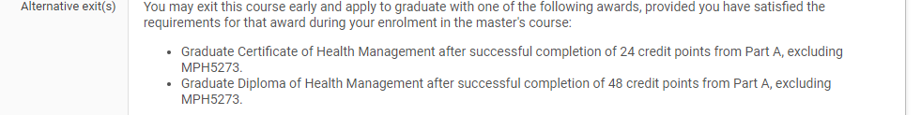

Professional accreditation

Examples of wording to be used are below:
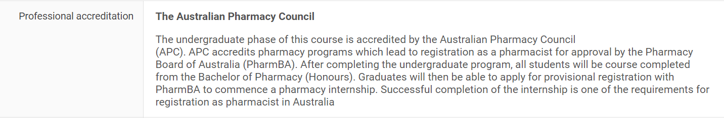

Progression to further studies

Examples of wording to be used are below:

Australian Higher Education Graduation Statement (AHEGS)

Examples of wording to be used are below:

