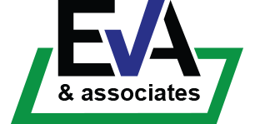
Fit Testing Medical Clearance Questionnaire

Your Details
Your Surname
Your First Name
Your Employee/Student Number
Email Address

Medical Clearance Questions
Have you ever had epileptic seizures? | YES | NO
Have you ever had an allergic reaction to any respirators/facemasks that affected your breathing? | YES | NO
Have you ever had an allergic skin reaction to any respirators/facemasks? | YES | NO
Do you have any history of skin, eye or airway irritation or allergies to materials or chemicals that may be in respirators/masks? | YES | NO
Whilst wearing a face respirator/face mask have you ever experienced claustrophobia? | YES | NO
Do you have any lung or respiratory disorders that could affect you wearing a face mask/respirator at work?  (e.g. Asthma) | YES | NO
Do you have any cardiovascular disorders that could affect you wearing a face mask/respirator at work? | YES | NO
Are there any medical or cultural reasons that prevent you from being clean shaven for your fit test and while wearing a respirator? | YES | NO
Do you anticipate any other problems that may interfere with your use of a respirator /face mask? | YES | NO

Sign ……………………………………………………………………..

Date ……………………………………………………………………..

