Audit of surveillance colonoscopy intervals
[INSERT AUDIT PERIOD e.g., 1 April 2024 to 30 June 2024]

[Date]

This report summarises concordance with the NHMRC-endorsed Cancer Council Australia Surveillance Colonoscopy Guidelines^{1,2} of surveillance interval recommendations made by endoscopists at [Health Service] and audited for the period [INSERT AUDIT PERIOD e.g., 1 April 2024 to 30 June 2024].
200 cases of colonoscopy were reviewed. 121 cases were excluded (not surveillance colonoscopy). 79 were recommended for future surveillance colonoscopy, had complete data to determine concordance and are included in this report.
The audit found, overall, 86% of patients were recommended a surveillance interval consistent with the guidelines for the current period
[FOLLOWING EACH AUDIT PERIOD, THE NUMBER OF CASES ABOVE SHOULD BE UPDATED TO RELFECT THE LATEST INFORMATION]
The figure below summarises overall guideline concordance for all endoscopists at [HEALTH SERVICE] for the current period [INSERT dates e.g., 1 Apr 2024 to 30 June 2024] and the previous audit period for comparison.
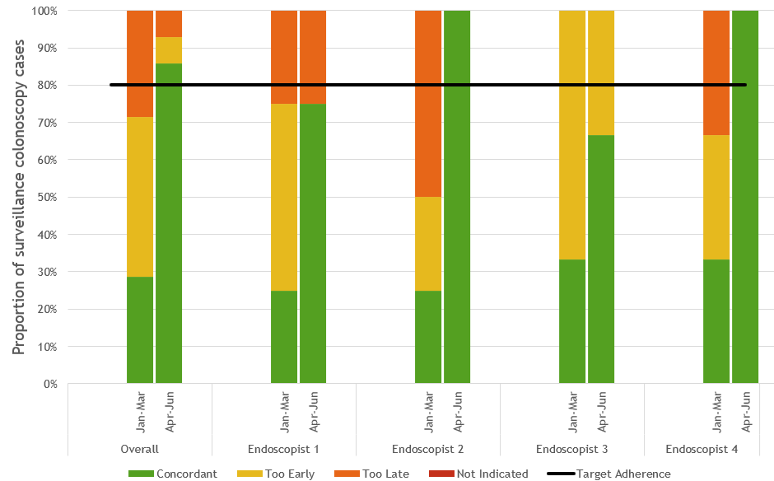
Reports containing individualised feedback on guideline concordance of surveillance interval recommendations will be provided to individual endoscopists. Best practice resources to support quality improvement are available at https://wiki.cancer.org.au/australia/Guidelines:Colorectal_cancer/Colonoscopy_surveillance.

Providing feedback on guideline concordance for surveillance interval recommendations to endoscopists is important as it promotes adherence to best practices, thereby enhancing the quality of care. This targeted approach helps reduce unnecessary procedures, optimises resource utilisation, and ultimately decreases waiting lists and the burden on patients. Access to best practice resources, such as those available on the Cancer Council Australia's Guidelines and Polyp app (https://www.polyp.app), supports continuous quality improvement and ensures that surveillance practices are up-to-date and evidence based.

References
¹ Cancer Council Australia (2018). Cancer Council Australia Surveillance Colonoscopy Guidelines Working Party. Clinical practice guidelines for surveillance colonoscopy. https://www.cancer.org.au/clinical-guidelines/bowel-cancer/surveillance-colonoscopy
² Cancer Council Australia (2023). Cancer Council Australia Colorectal Cancer Guidelines Working Party. Clinical practice guidelines for the prevention, early detection and management of colorectal cancer. https://www.cancer.org.au/clinical-guidelines/bowel-cancer/colorectal-cancer

