

Annual Report* of IGCP Project No. 587

.
Send to UNESCO and IUGS
ml.faber@unesco.org
iugs.beijing@gmail.com
by 01/12/2016
IGCP project short title:

IDENTITY, FACIES AND TIME – THE EDIACARAN (VENDIAN) PUZZLE

Duration: 2010-2015, 2016

Please tick this box if the report is for a Project on extended term (OET):

Project leader(s):

Dr Patricia Vickers Rich
School of Earth, Atmosphere and Environment
Monash University, Melbourne (Clayton), Victoria 3800 Australia
Tel.: +61 412 230 624
FAX: +61 3 9905 4903
pat.rich@monash.edu

Dr Mikhail A. Fedonkin
Geological Institute & Paleontological Institute, Pyzhevskiy, 7, and Profsoyuznaya ul. 123
Russian Academy of Sciences, Moscow, 119017 & 117997, Russia
Tel.: +7 095 339 9566
FAX: +7 095 339 1266
fedonkin@ginras.ru
mfedon@paleo.ru

Prof. Guy Narbonne
Department of Geological Sciences and Geological Engineering
Queens University, Kingston, Ontaria K7L3N6, Canada
Tel.: +1 613 533 6168
FAX: +1 613 533 6592
narbonne@geol.queensu.ca

Dr Jim Gehling
South Australian Museum
North Terrace, Adelaide, South Australia 5000 Australia
Tel.: +61 8 8207 7441
FAX: +61 8 8207 7222
Gehling.jim@samuseum.sa.gov

Dr Alan Jay Kaufman
Department of Geology and Earth System Science Interdisciplinary Center
University of Maryland, college Park, Maryland 20742-4211 USA
Tel.: +1 301 405 0395
FAX: +1 301 405 3597
kaufman@geol.umd.edu
.

Project Secretary:

Dr Patricia Vickers Rich
School of Earth, Atmosphere and Environment
Monash University, Melbourne (Clayton), Victoria 3800 Australia
Tel.: +61 412 230 624
FAX: +61 3 9905 4903
pat.rich@monash.edu

Date of submission of report: 21 November 2016

Signature of project leader(s): 

ANNUAL REPORT

1. Website address: http://monash.edu/science/about/schools/geosciences/precsite/html

2. Summary of major past achievements of the project

See website, which details each year of IGCP587 plus its precursor IGCP493.

This project has from the beginning aimed to extend the work begun by IGCP493 (2003
-2009) in attempting to locate additional material from areas with a sparse Ediacaran biotic record (South America, Middle East, Siberia, Mongolia, Iran), but with marked palaeobiogeographic interest; to closely compare those settings (using sedimentology and detailed basin analysis, carbon and oxygen isotope input, palaeogeography) with faunas from some of the most abundant Ediacaran biotas have been collected. This project has allowed the proposers and associates to increase significantly the data base (and stimulate further discussion and joint research) of some of those less biodiverse, yet specimen abundant, assemblages, such as those in Namibia, Newfoundland, the Flinders Ranges of Australia and the White Sea in Russia, as well as classic sites in the Ukraine, China, and NW Canada. The project has attempted t to push further back in time and examine older assemblages as well as slightly younger in the Cambrian. IGCP587 has put much effort into involving students and non-scientists, artists, documentary makers (including Sir David Attenborough and the BBC), as well as seasoned researchers in this project in the hope of markedly increasing the amount of material from some of the lesser known locales, refining the dating of all of these locales, and popularizing the research results to a broader audience. By understanding the sequence and more precise timing of biotic events during the Neoproterozoic and their drivers, wisdom concerning our future predictions of climate and habitability of the Earth is a natural by-product and a road-map for behaviour of humans.

3. Achievements of the project this year only

Petrographic and Geochemical Analysis of the latest Neoproterozoic carbonate sequences in southern Africa by Jay Kaufman/Les Krisfeld and their teams from the University of Maryland and Monash University. The emphasis for this project is to better understand the driver(s) of the Ediacaran Shuram Excursion, the most negative carbon isotope anomaly in Earth history. Field observations and carbon isotope measurements of calcite nodules lined with silica cements (Fig. 1) in the Mara Member of the Nama Group in southern Namibia (Fig. 2) suggest an early authigenic origin associated with the oxidation of methane within the sulfate-methane transition zone of sediments. These measurements suggest that the release and anaerobic oxidation of methane (with sulfate) from gas hydrate deposits in the middle Ediacaran may explain the unique carbon cycle anomaly, which neatly subdivides the period and may have paved the way for the evolution of Ediacaran animals.

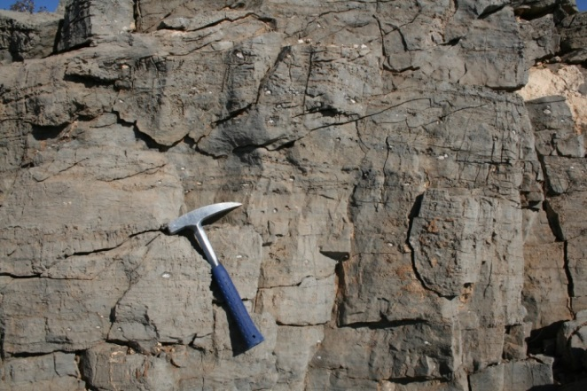

Fig. 1: Silica- and pyrite-lined calcite nodules in dolomicrite from the Mara Member of the Nama Group in southern Namibia. The carbon isotope compositions of the nodules suggest an authigenic origin from the oxidation of organic matter, including methane, near the sediment/water interface through microbial sulfate reduction. This may be evidence of Earth’s earliest methane cold seep environments, and is similar to field and laboratory measurements of similar nodules in Shuram equivalent strata of South China by Kaufman and colleagues (in review; GSA presentation and abstract).

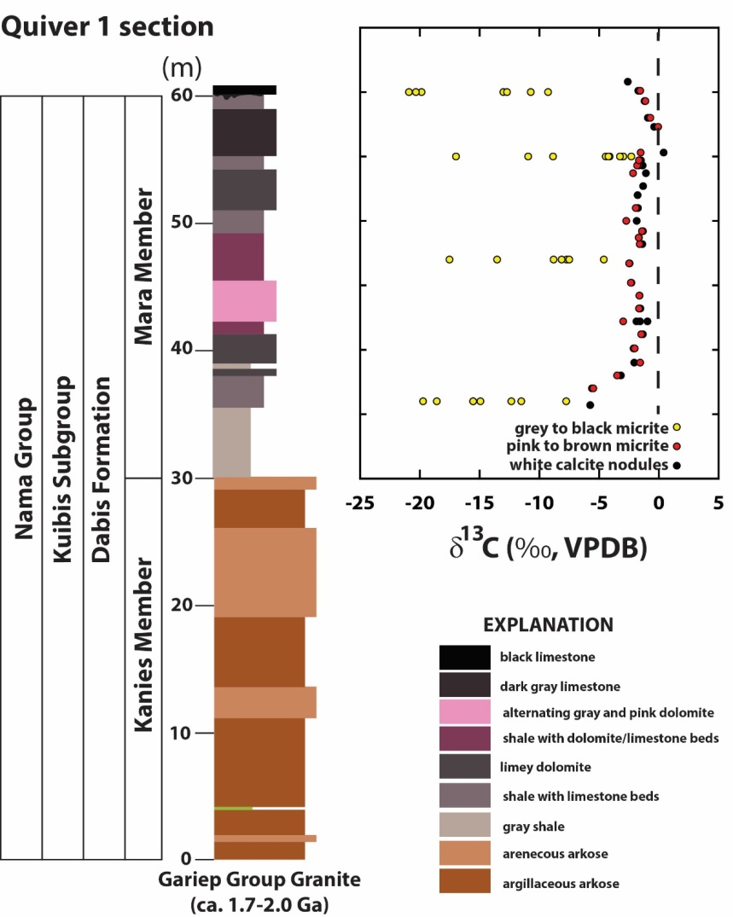
Fig. 2: Measured stratigraphy and carbon isotope compositions of micrite, dolomicrite, and calcite nodules in the Mara Member at the Quiver locality in southern Namibia. The strongly negative δ¹³C values of the nodules supports their origin as authigenic precipitates and suggests that the oxidation of methane and organic matter through microbial sulfate reduction may explain the enigmatic Shuram Excursion.

Synchrotron Imaging of Namibian Ediacarans. Further , four-day sessions at the Australian Synchrotron in Melbourne involved the scanning of several specimens of Rangea, Pteridinium, Nemianaand Ernietta from the Nama Group of Namibia. Other surface scans of Rangea were carried out at Monash University and currently the internal structure made on the synchrotronis complete and a paper is near completion on this headed by Dr Alana Sharp. Mineralogical studies being carried out by Dr Sioban Wilson will be included in this paper along with thin section and sedimentalogical analyses. The surface scans have made it possible to provide 3d prints to a number of museums around the world where original material is not present.

Detailed planning for the preconference field trip of the International Geological Congress in the Nama Group – and production of the field guide and logistics for this trip that will take place in August of 2016.

3.1. General scientific achievements
(Meetings are not considered as scientific achievements, they should be listed under heading 3.3.)
- Published a significant number of papers as a direct result of activities related to IGCP587 – see appendix for a selection.

- Success of of a UNESCO World Heritage Proposal for Mistaken Point, Canada. Thomas, R., and Narbonne, G.M. 2015, Mistaken Point: Nomination for inscription on the UNESCO World Heritage List, 165 pages + 650 page appendix. (also noted in 3.7).

- Submission of Cui, H., Kaufman, A.J., Xiao, S., Peek, S., Cao, H., Min, X., Cai, Y., Siegel, Z., Liu, X.-M., Schiffbauer, J.D., and Martin, A. (in review) Environmental context for the terminal Ediacaran biomineralization of animals. Geobiology.

- Submission of Cui, H., Kaufman, A.J., Xiao, S., and Zhou, C. (in preparation) An authigenic response to Ediacaran surface oxidation. Earth and Planetary Science Letters.

- Submission of Gaschnig, R.M, Rudnick, R. L., McDonough, W.F., Kaufman, A.J., Valley, J., Hu, Z., Gao, S., and Beck, M. (in review) Compositional evolution of the upper continental crust constrained by ancient glacial diamictites through time. Geochimica et Cosmochimica Acta.

3.2. List of IGCP project meetings/symposia and IGCP related meetings/symposia

Main effort in 2015 and 2016 was preparation for the preconference field trip on the Nama Group, late Neoproterozoic, in Namibia prior to and part of the International Geological Congress to be held in Cape Town. This field trip was a signiricant success for this project and a copy of the field guide is attached.

3.3. Educational, training or capacity building activities related to the IGCP project and IGCP project participants.

Hinder, G., Vickers-Rich, P., van Schalkwyk, P. & Schneider, G., 2016. A Worldclass Canyon and Late Proterozoic “Ghosts”, Superlatives of the Nama Group. Heritage Volume for International Geological Congress, Cape Town, South Africa 2016.

See Section 8 below for additional programs that both brought in funding for IGCP587 and also provided significant public outreach. Beyond that the PrimeSCI! outreach educational group based at both Monash University and Swinburne Unviersity (both in Melbourne) have programs that highlight the results of IGCP587 not only in Australia but also in Africa, the Middle East and Southeast Asia.

Helen Boynton reported on a renewed project of both scanning and producing new moulds of material preserved in the Blackbrook Formation, Charnwood forest, noted in an article in the September issue of Charnia, page 3. This insures cast material can be distributed to collections around the world and assists in keeping records where erosion or even vandalism can destroy critical fossils. Aaron Bowers continues his exploration of the Charnwood area, with ever new finds.

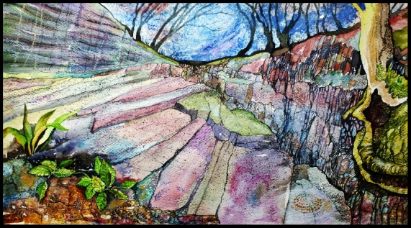 Painting of Charnwood outcrop by Tina Negus. See article in Appendix about the discovery of the Charnwood fossils in Leicester.

3.4. List of countries involved in the project (*indicate the countries active this year)

*Argentina, *Australia, *Brazil, *Canada, *China, Czech Republic, *Germany, *India, *Iran, Iraq, Ireland, Italy, Japan, *Namibia, The Netherlands, Poland, *Russia, *Saudi Arabia, Spain, *Sweden, *South Africa, Taiwan (Republic of China), *Timor-Leste, *United Kingdom, *Ukraine, Uruguay, *USA

3.5. Participation of scientists from developing countries, and in particular young and women scientists: exact number and please describe how this project specifically benefited women scientists, young scientists and/or scientists from developing countries

3.6. List of the 5 most important publications
Ivantsov, A.Yu., Narbonne, G.M., Trusler, P.W., Greentree, C., and Vickers-Rich, P. 2016, Elucidating Ernietta: Exceptional specimens from the Ediacaran of Namibia. Lethaia, 49: 540-554.
Sperling, E.A., Carbone, C., Strauss, J.V., Johnson, D.T., Narbonne, G.M., and Macdonald, F.A., 2016, Oxygen, facies, and secular controls on the appearance of Cryogenian and Ediacaran body and trace fossils in the Mackenzie Mountains of northwestern Canada. Geological Society of America, Bulletin, 128: 558–575.
Thomas, R., and Narbonne, G.M., 2016, Mistaken Point: Nomination for inscription on the UNESCO World Heritage List, 165 pages + 840 page appendix. Available online at <http://whc.unesco.org/uploads/nominations/1497.pdf>.
Vickers-Rich, P., Narbonne, G., Laflamme, M., Darroch, S., Kaufman, A. J., and Kriesfeld, L., 2016. The Nama Group of Southern Namibia. The End Game of the First Large, Complex Organisms on Earth, the Ediacarans [IGCP493/587]. 35th International Geological Congress, 2016 Pre-conference Field Guide, 21-25 August, Namibia, International Geological Congress Guidebook with New Artworx, Cape Town, South Africa: 1-16.
Xiao, S., Narbonne, G.M., Zhou, C., Laflamme, M., Grazhdankin, D.V., Moczydłowska-Vidal, M., and Cui, H., 2016, Toward an Ediacaran Time Scale: Problems, Protocols, and Prospects, Episodes, 39:540-555.
See attached selected bibliography for 2015, as an appendix.

3.7. Activities involving other IGCP projects, UNESCO, IUGS or others

Neoproterozoic Subcommission https://www.jcu.edu.au/mailman/listinfo/neoproterozoicsubcommission Prof. Guy Narbonne served as the Chair of the newly formed IUGS/ICS Working Group on a Terminal Ediacaran Stage. He represented our IGCP project at the International Commission on Stratigraphy Congress (Graz, Austria) where hegave talks on “Towards a Terminal Ediacaran Stage” and “New Developments at the Basal Cambriarn GSSP, Fortune Head, Newfoundland, Canada”. Prof. Kaufman is also a member of this subcomission and attended the meeting in Graz, Austria. There was another gathering of participants of this working group at the Pre-conference field trip on the Nama Group in August 2016.

3.8. Scientific Legacy: Is there a need for storage of publications, field data, and other results of the project? Do you have a clear vision concerning where the data would be stored and who will be the custodian?

In most all cases, fossil material is stored in the country of collection, in such places as geological surveys (e.g. Namibia, in the Namibian Geological Survey where there has been a concerted effort to curate and outfit the museum there with storage racks, furniture, filing systems), or museums (the South Australian Museum and Museum Victoria in Australia) , or government institutes (such as the Paleontological Institute, Russian Academy of Sciences). There has also been significant effort in the case of paleontological specimens to scan both external and internal structures and produce 3d prints and data files and these made available to institutions around the world. More of this is to be encouraged.

3.9. What tangible improvements has your project obtained? (Besides publications, we are interested to hear about improvements to research, scientific contacts, policy implications, etc)

Iran
Analysis of the material collected on the 2015 field excursion to the Erborz Mts of northern Iran and the Yazd area with the Iranian Geological Survey was one of the highlights of 2016, paving the way for further engagement in future. The Iranian Geological Survey provided all of the ground support in 2015, vehicles and local staff as well as the connections with district governance and mining companies that gave free access to locales that had not been explored before or only in the 1980’s by foreign researchers. 2016 was spent analyzing the specimens collected on the 2015 expedition and a publication is near completion and will be submitted to Alcheringa by early December 2016.

South Australia
Ediacara research in South Australia has continued with further excavations at the National Heritage Listed Ediacara Fossil Site at Nilpena, a new site in the northern Flinders Ranges of South Australia, and for the first time, at the historic discovery site in the Ediacara Conservation Park. At Nilpena, our teams from University of California, Riverside and the South Australian Museum, have excavated, inverted and reassembled 24 beds for palaeoecological analysis, since 2003. In four excavation sites, this has produced serial beds for assessment of heterogeneity of benthic assemblages of these late Ediacaran benthic assemblages. Ediacaran fossil sites across the Flinders Ranges are being studied to assess onshore to offshore variations in faunal assemblages. Bedding excavations have proven to be the only effective means of assessing the body fossil composition of beds at all scales, since taxa vary from less than 5mm to more than two metres in dimensions. Research has been led by Jim Gehling, and Mary Droser with Diego Garcia-Bellido recently joining the research group along with several post-doctoral fellow, Lidya Tarhan, and graduate students including, Scott Evans, Christine Hall, Felicity Coutts, and Lily Reid. Visiting researchers to SA Museum and the Flinders Ranges Ediacara sites have included Guy Narbonne, Alex Liu, Alex Dececchi. Doug Erwin, Jon Antcliff and Jennifer Hoyal-Cuthill.

The iconic Ediacara fossil: Spriggina floundersi has been proposed as a candidate for the fossil emblem of the state of South Australia in acknowledgement of its interpretation as the first known Ediacaran organism with a head, and in honour of the late Reg Sprigg, who first realized the Ediacara biota in 1947, and for his pioneering geological and environmental achievements.

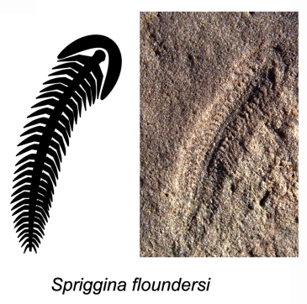
3.10. What kinds of activities in respect to the benefit of society and science outreach has your project undertaken? See Section 8 below as well as this list.
Success of the Submission of a UNESCO World Heritage Proposal for Mistaken Point, Canada! Thomas, R., and Narbonne, G.M. 2015, Mistaken Point: Nomination for inscription on the UNESCO World Heritage List, 165 pages + 650 page appendix.
A proposal to have Farm Aar declared as a Namibian National Heritage site, jointly presented
with the Namibian Geological Survey, Ministry of Mines and Energy, was successful, and this listing was successful in 2014. Now there is effort to follow this up and apply for UNESCO heritage listing. Farm Aar along with Swartpunt and the surrounding area is by far the most prolific area for the last occurrence of large metazoans, unshelled, globally and the richest site on the African continent – a project tentatively titled – the Cradle of Modern Animalia. A small museum is currently in place on Farm Aar, and there is growing effort to set up a heritage museum in the town of Aus, near Farm Aar. Significant local and national interest is current and the possibility of permanently setting aside Farm Aar as a Heritage site staffed by locals and open for limited and controlled eco-tourism is underway. With the locals and national heritage organizations a long term history of this region is being compiled with emphasis on the geological aspect of this heritage. The pre-conference field trip for the 35th IGC to the sites under consideration was a step forward in this proposal. Locals in this regtion are most supportive of this.

July 2015-July 2017. Exhibition Wildlife of Gondwana on show at the National Wool Museum in rural Victoria, Geelong, Australia. This exhibition showcases current research on the Precambrian with inclusion of documentaries produced on the field work carried out by IGCP587 participants.

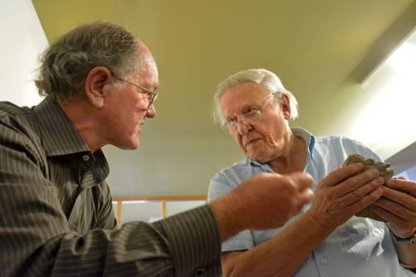
Trusler discussing the reconstruction of Rangea from Namibia with David Attenborough, information used in First Life and on show at the exhibition in Geelong.

3.11. What kind of public information (media reports, etc) has your project generated? And how do you evaluate their impact?

Each of the exhibitions produced significant media, which impacted on the local community and encouraged attendance to both of the exhibitions on show during 2016 and ongoing. Media was certainly attracted in Cape Town at the 35th IGC meetings in response to posters presented by IGCP587 participants and likewise at the PaleoDownUnder 2 meetings in Adelaide. More media was attracted by the public lectures at the Singapore Science Centre, the National University of Singapore (one given at the Botanical Gardens in Singapore) and the exhibition on show at the regional National Wool Museum in Geelong, Victoria, Australia.

4. Activities that took place

Meetings

Palaeo Down Under2. July 2016. Association of Australasian Palaeontologists (AAP) organizied a Palaeo Down Under 2 conference at the University of Adelaide in South Australia from July 10-15. The conference was preceded by a Field Excursion to key Cambrian localities of Kangaroo Island, the Fleureu Peninsula and the Cambrian and Ediacaran of the Flinders Ranges from July 3-9. A large number of papers concerning the Ediacaran were presented at this most successful conference and the Field Guide developed for the pre-conference excursion was outstanding.

International Geological Congress, August 2016. Excursion SA_Pre2 Nama Group geology and Ediacaran fossils Coinciding with the late stage of the orogenys that welded together the Gondwana supercontinent, a huge sedimentary basin developed in southern Namibia and accommodated the molasse derived from the uplifted orogenic areas. The shallow sea that formed would become the scene of early life growing up, as more complex creatures developed in a World that hitherto only knew single-celled live. As a result, the Nama Group hosts the fossil remains of some of the World’s oldest known multi-cellular organisms, the metazoan communities of the so-called Ediacaran age. This field trip was specifically aimed at studying the environments of the life forms of the Ediacaran fauna in the Nama Group sediments of the terminal Proterozoic (terminal Ediacaran). The trip concentrated on the south of Namibia, and the sedimentology of the Nama Group was investigated on the way from Windhoek. The terminal Ediacaran fossils at the national heritage site of Farm Aar,at Farm Pockenbank and Swartpunt were examined by a completely sold out conference. The field guide attached was deemed “spectacular” by Dr Greg Botha, the head of the team organizing the 35th IGC. . The excursion included a short visit to the Nama section at Fish River Canyon And Ai-Ais.

Field Trip Leaders: Pat Vickers-Rich, Guy Narbonne, Marc Laflamme, Simon Darroch, Alan Jay Kaufman and Les Kriesfeld.
Start/end: Windhoek
Date: 5 days, 21-25 August 2016

Cost: $Namibian 13,890.00http://www.35igc.org/Page/206/ExSAPre2-Nama-Group-geology-and-Ediacaran-fossils

5. Project funding requested:

No funding requested. OET requested so that the final year of this project will be 2016 in association with the International Geological Congress, Cape Town.

6. Request for extension, on-extended-term-status, or intention to propose successor project:

This is the final year of IGCP587.
7. Financial statement ($ USD only).

No funds were requested from UNESCO.

8. What additional funding besides the IGCP seed funding has your project obtained thanks to the IGCP label? Please estimate the budget received for meetings, research or other and identify the source.

Funds from donations and in kind support to underwrite two field trips from August-November in the Elborz Mountains as well as the Yazd region of Iran (in conjunction with the Iranian Geological Survey) and a second in southern Namibia (Nama Group) (in conjunction with the Namibian Geological Survey. $US35,000+. These funds were further used in the preparation of the preliminary paper on the Iranian exploration field trip and more have been requested for another trip in 2017. Funds for that work in 2017 in Iran have been offered for inkind logistics by the Iranian Geological Survey.

Exhibition income from National Wool Museum where Wildlife of Gondwana Exhibition in place from July 2015 to July 2016 and this was extended to July 2017 - highlighting Neoproterozoic material from South and Western Australia, Namibia, Russia, much collected as a result of expeditions carried out under IGCP493 and 587. Much of this was used to underwrite further field work and development of educational materials highlighting results of IGCP projects. $Aust. 70,000 with another $50,000 due in late 2016 for the exhibition to continue until July 2017. It is planned that the exhibition will remain permanently at the Geelong Wool Museum and an ancient life trail will be developed that will lead from the present, along the southern coast of Australia (the Great Ocen Road) ending eventually in the Flinders Ranges where the Ediacaran biota is classic.

20 – 25 January 2016. Visit of the explainer team from Timor-Leste for training in presentation of fossil exhibition now in the UNESCO headquarters in Dili where cast material of Ediacarans derived from IGCP493 and 587 are on display. Funding for the visit was provided by PrimeSCI!, and educational unit based at Monash University in the School of Earth, Atmosphere and Environment and a grant from UNESCO, part of the grant from 2015 a UNESCO grant for $US18,000 Timor-Leste’s Long History & Geology Exhibition: School Visits Program provided professional development for primary and secondary teachers and training for the curators of the O Mundo Perdido Exhbitions established by the Monash Science Centre/PrimeSCI! in the capital Dili in the UNESCO Headquarters, in the Public Library in the highland town of Aileu (a joint project with the Moreland City Council VLGA) and at the Don Bosco Catholic Centre in Baucau.

14-20 May 2016. Workshop on Promoting Earth Science in Kenyan Schools, sponsored by UNESCO and the Government of Kenya. See attached report. As part of the presentation provided by PrimeSCI! and Monash University delegates, the research funded by IGCP587 was offered as part of the developing curriculum for Primary, Secondary and Tertiary education in that country. @US$12,000+ for transport and accommodation of the presentation team.

15-29 June 2016. Participants in IGCP587 presented a series of public lectures and workshops at the National University of Singapore, a joint project of the College of Alice and Peter Tan and the Lee Kong Chian Natural History Museum which highlighted research and the paleontological art of Dr Peter Trusler – funding included airfares, accommodation, per diem expenses and salaries for the time (@US$13,000+).

20 – 28 July 2016. Presentation by several participants of IGCP587 at the Visual SG Conference at the Singapore Science Centre, again highlighting the paleoart of Dr Peter Trusler, an IGCP587 participant. This conference explored the many different ways of depicting science in many different visual formats. See attachment of one presentation at the SSC as part of the Science in the Cafe which took place simultaneously. Funding provided by the Singapore Science Centre for 3 participants (@$Sing. 10,000).

30 July – 19 September, 2016. Field expenses, travel expenses for Namibian Field Conference Preparation, attendance at 35th IGC for several participants of IGCP587 and Research with Russian colleagues at the Paleontological Institute in Moscow, funding derived from both the IHCP Australian Committee and private donations, @US$25,000 +.

9. Attach any information you may consider relevant (See Attached Documents)

a. Nama Field Guide for pre-conference field trip, Aug. 2016.
b. Nama Field trip final report, Aug. 2016.
c. Science in the Cafe, Singapore, 2016.
d. Workshop on Promoting Earth Science in Kenyan Schools.

Bibliography

Elliott D. A., Trusler P., Narbonne G.M., Vickers-Rich P., Fournie N., Hoffmann K. H., and Schneider G., 2016, Ernietta from the late Ediacaran Nama Group, Namibia. Journal of Paleontology, 89: 1017–1026.
Ivantsov, A.Yu., Narbonne, G.M., Trusler, P.W., Greentree, C., and Vickers-Rich, P. 2016, Elucidating Ernietta: Exceptional specimens from the Ediacaran of Namibia. Lethaia, 49: 540-554.
Mason, S.J. and Narbonne, G.M., 2016. Two new Ediacaran fronds from Mistaken Point, Newfoundland, Journal of Paleontology, 90: 183-194
Elliott D. A., Trusler P., Narbonne G.M., Vickers-Rich P., Fournie N., Hoffmann K. H., and Schneider G., 2016, Ernietta from the late Ediacaran Nama Group, Namibia. Journal of Paleontology, 89: 1017–1026.
Pandey, S. K. and Sharma, M., 2016. Enigmatic Ediacaran megascopic bedding plane structures on the Sonia Sandstone, Jodhpur Group, Marwar Supergroup, India: seaweed or probematica? Geological Journal, DOI40.: 10.1002/gi.28
Sperling, E.A., Carbone, C., Strauss, J.V., Johnson, D.T., Narbonne, G.M., and Macdonald, F.A., 2016, Oxygen, facies, and secular controls on the appearance of Cryogenian and Ediacaran body and trace fossils in the Mackenzie Mountains of northwestern Canada. Geological Society of America, Bulletin, 128: 558–575.
Thomas, R., and Narbonne, G.M., 2016, Mistaken Point: Nomination for inscription on the UNESCO World Heritage List, 165 pages + 840 page appendix. Available online at <http://whc.unesco.org/uploads/nominations/1497.pdf>.
Vickers-Rich, P., Narbonne, G., Laflamme, M., Darroch, S., Kaufman, A. J., and Kriesfeld, L., 2016. The Nama Group of Southern Namibia. The End Game of the First Large, Complex Organisms on Earth, the Ediacarans [IGCP493/587]. 35th International Geological Congress, 2016 Pre-conference Field Guide, 21-25 August, Namibia, International Geological Congress Guidebook with New Artworx, Cape Town, South Africa: 1-16.
Xiao, S., Narbonne, G.M., Zhou, C., Laflamme, M., Grazhdankin, D.V., Moczydłowska-Vidal, M., and Cui, H., 2016, Toward an Ediacaran Time Scale: Problems, Protocols, and Prospects, Episodes, 39:540-555.

