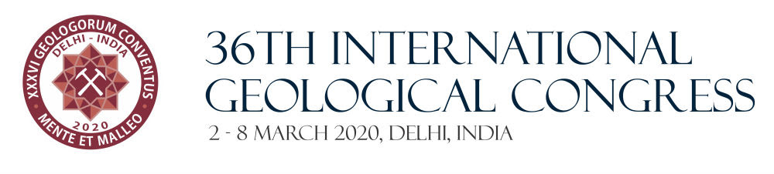
Dear Dr. Patricia Rich
This is to inform you that your abstract has been submitted successfully and is in the process of review.
The details submitted by you as follows:
Abstract Number | 3312
Author Name | Dr. Patricia Rich
Title | FROM WEIRDNESS TO THE MODERN WORLD – 538 MILLION YEARS AGO ON OUR PLANET
Topic | Theme 1: Symposium 1.12 The roles of UNESCO, IGCP and IUGS in realizing the UN Sustainable Development Goals (Symposium proposed by UNESCO-IGCP-IUGS)
Submission Preference | E-Poster
Please quote your abstract number for all future communications.
Should you require any assistance please feel free to write to us at abstract@36igc.org
Thanking you,
36th IGC Secretariat.


