Brief Overview

Pacific Indicators for Disability-Inclusive Education 2016
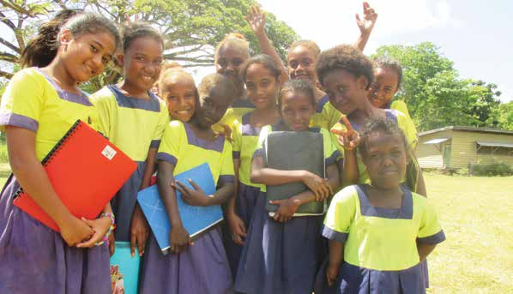
CBM – Nossal Institute Partnership for Disability Inclusive Development
Pacific Disability Forum
Pacific Islands Forum Secretariat
Monash University

Authors
Umesh Sharma, Chris Forlin, Manjula Marella, Beth Sprunt, Joanne Deppeler, and Filipe Jitoko.
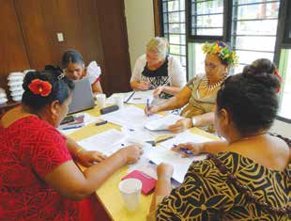

Acknowledgements
The Pacific-INDIE guidelines have been developed in partnership by Monash University, CBM – Nossal Institute Partnership for Disability Inclusive Development, Pacific Disability Forum, and the Pacific Islands Forum Secretariat. We would like to acknowledge the significant contributions of Mr. Setareki Macanawai, Ms. Angeline Chand and Mr. Shane Antonio from Pacific Disability Forum (PDF) Fiji for ongoing support and seamless co-ordination of activities in the Pacific case study countries. We would also like to acknowledge the support provided by Mr. Laisiasa Merumeru and Mr. Michael Sivendra from Pacific Islands Forum Secretariat (PIFS) throughout the project. We would like to acknowledge the contributions of Fiji Disabled Peoples Federation and the Ministry of Education, Fiji; Nuanua O Le Alofa (NOLA) and Ministry of Education, Samoa; Ministry of Education and Human Resource Development, People with Disabilities Solomon Islands (PWDSI) and the Solomon Islands National University; and Disability Promotion and Advocacy Association and the Department of Education, Vanuatu.

In particular, we would like to acknowledge the contributions of our Associate Country Investigators:
- Kitione Ravulo (Corpus Christi Teachers College) and Savaira Tinaivunivalu (Fiji Disabled Peoples Federation) from Fiji;

- Mailo Pesamino (Ministry of Education), Faaolo Utumapu-Utailesolo (NOLA), and Ailini Ioelu (Ministry of Education) from Samoa;
- Janine Simi and James Porakari (Solomon Islands National University), George Saemane (Florence Young Christian School), Simon Dolaiano, and Casper Fa’asala (People with Disabilities Solomon Islands) from the Solomon lslands; and
- George Maeltoka, Glenden Ilaisa (Ministry of Education) and Freda Willie (Disability Promotion Advocacy and Awareness) from Vanuatu.

We would also like to thank Professor Tim Loreman, Professor Roger Slee, Professor Lani Florian, Professor Martyn Rouse, Professor Richard Rose, Mrs. Karen Underwood, Dr. Susie Miles, Professor Spencer Salend, Mr. Rick Frost, Dr. Keshari Narain Ojha, Dr. Amanda Watkins and UNICEF Pacific for their contributions and assistance in the research as expert consultants which informed these guidelines.

A number of people from CBM-Nossal Partnership for Disability Inclusive Development were involved in the ongoing review process including Hasheem Mannan, Tamara Jolly, Sally Baker, Matthew Allen, Amanda Benson, Joanne Webber, Tanya Edmonds and Lisa Fitzgerald. Their support is gratefully acknowledged.
This research has been funded by the Australian Government, through the Department of Foreign Affairs and Trade’s Australian Development Research Awards Scheme (ADRAS), under number 66440 an award titled ‘Developing and testing indicators for the education of children with disability in the Pacific’. The views expressed herein are those of the author(s) and not necessarily those of the Commonwealth of Australia. The Commonwealth of Australia accepts no responsibility for any loss, damage, or injury resulting from reliance on any of the information or views contained in this publication.
Australian Government, Department of Foreign Affairs and Trade
Australian Aid

Contents

Brief Overview 1
Pacific Indicators for Disability-Inclusive Education 2016 1
Authors 2
Acknowledgements 2
Contents 4
Introduction 5
Key principles in developing the Pacific-INDIE 6
Defining Disability- Inclusive Education 6
What is an Indicator? 7
Disability-Inclusive Education in the Pacific Islands 7
Selecting Indicators 8
Structure of the Pacific- INDIE and Guidelines 9
Implementing the Indicators 10
Contact us 15

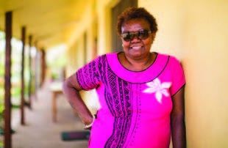
‘The final set of indicators in this publication can be viewed with confidence as relevant and realistic to the Pacific context as developed by Pacific people. The Pacific-INDIE will support Pacific states in their own monitoring of national efforts towards building more inclusive education systems that will allow persons with disabilities greater access to mainstream schools without barriers.’
Nelly Caleb
Co-Chairperson, Pacific Disability Forum

Introduction
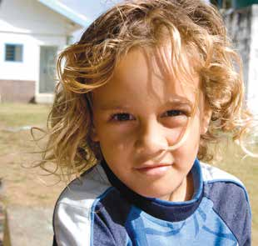
This is an abridged version of the Pacific Indicators for Disability-Inclusive Education (Pacific-INDIE) guidelines. The Pacific-INDIE are a resource to support Pacific Island countries in a process of developing disability-inclusive education. A set of Guidelines have been prepared for administrators (e.g. Ministry or regional level), senior leaders (e.g. principals) and operational staff (such as teachers) to be used in collaboration with other relevant professionals, parents and community stakeholders such as Disabled Persons Organisations (DPOs) to measure progress towards implementing disability-inclusive education. The Guidelines are divided into three parts:

- Part A: Introduction and Background
provides the rationale for developing the Pacific Indicators. It addresses the reasons why disability-inclusive education is so pertinent in the Pacific and how the indicators may be used as a way to measure progress and plan to implement effective inclusive education.
- Part B: Guidance for stakeholders gives guiding principles for using the indicators for measuring disability-inclusive education in the Pacific Islands.
- Part C: The Indicators presents indicators with specific information, directions and practical steps for implementing and measuring them. There are 48 indicators spread over 10 dimensions of disability-inclusive education.
You are highly recommended to read the Pacific-INDIE document in full for more details about the Indicators and how to apply them in your country. These are freely available to download from the Monash University Website.
The development of indicators took place over three years through a systematic process. It involved undertaking a series of literature reviews; in–country consultations with key Pacific stakeholders; data collections through interviews with parents and members representing DPOs, primary and secondary school educators, teacher educators; and, surveys of Ministerial representatives from 14 Pacific countries. Various drafts of the Pacific-INDIE were reviewed by Pacific and International experts throughout the development phase and revised
in consultation with our Pacific partners and researchers. For a detailed description of the methodology used to develop the indicators please refer to Part A of the Pacific-INDIE at Monash University Website.

Key principles in developing the Pacific-INDIE
Three key principles provided the foundation to developing the Indicators:
- Collaboration;
- A need for system change; and
- Nothing about us without us: The leadership role of Pacific Islanders.

Defining Disability- Inclusive Education
Approaches to determining disability amongst children with disabilities vary tremendously across the Pacific, as they do around the world. It is an important process for each Pacific Island government, in collaboration with Disabled Persons Organisations (DPOs) and other disability stakeholders, to review existing laws, policies and practices that have relevance for how disability is defined.
As countries increasingly implement disability-inclusive education, the methods of determining disability often need to be more formalised as many more children with disabilities will access schools. However, it is critical that the process does not lead to over identification of children as having a disability. We define disability-inclusive education as:
- Disability-Inclusive Education is the means by which the rights of children and youth with disabilities to education are upheld at all levels within the general education system, on an equal basis with others in the communities in which they live. It involves identifying and overcoming barriers to quality education in the general education system; reasonable accommodation of the individual’s requirements; and provision of support measures to facilitate access to and participation in effective quality education.
In order to measure progress in disability-inclusive education by using the Pacific-INDIE a clear and agreed upon country definition of disability is essential.
To achieve disability-inclusive education, challenges have to be addressed beyond the boundaries of the school and classroom. Education and other government systems, DPOs and whole communities need to work together to ensure equality of access for children with disabilities.

What is an Indicator?
Indicators can provide important information which can be used to improve decision making. It is important, however, to remember that indicators only indicate, they do not explain.
In education, indicators may be direct, such as reporting on the numbers and percentage of children attending (or not attending) school regularly, or they may be indirect, using so-called proxy indicators. For example, the number of children completing primary school may be seen as a proxy indicator of effective teaching and learning.
The Pacific-INDIE is designed to assist countries in not only setting targets to promote the inclusion of children and youth with disabilities. The indicators could also be used by participating countries in determining how best the set priorities could be achieved. The Pacific-INDIE allows for collaboration amongst a range of stakeholders in identifying strategies that might work within their contexts to implement disability inclusive education.

Disability-Inclusive Education in the Pacific Islands
Through the Pacific Education Development Framework (PEDF) approved by all Pacific Island Education Ministers in 2009, special and inclusive education are seen as a priority, thereby endorsing a rights based and inclusive approach to disability and education for all learners. The 14 member countries of the Pacific Island Forum have adopted this Framework and agreed to work towards disability-inclusive education at a regional level.
The Pacific-INDIE is designed to assist countries in measuring and reporting progress of their targeted development efforts towards disability-inclusive education. The Pacific-INDIE provides important information which can be used to improve decision making within each country. The Pacific-INDIE not only helps to set targets to promote the inclusion of children and youth with disabilities but can also be used in determining how best the set priorities could be achieved. The indicators provide as far as possible a standard reporting format across the Pacific Islands to measure region-wide progress towards disability-inclusive education.
The indicators have been developed to align with country educational policies and other Pacific regional processes outlined in the PEDF and the priorities of disability and education stakeholders in the Pacific.

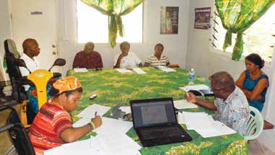

Selecting Indicators
There are a total of 48 indicators developed specifically to measure progress towards disability-inclusive education in the Pacific Island countries. These have been developed to supplement, align and assist with the implementation of the PEDF vision of Quality education for all in Pacific Island countries and the PEDF three strategic goals of:
- To achieve universal and equitable participation and access to Pacific education and training (Access & Equity).
- To improve quality and outcomes (Quality).
- To achieve efficient and effective utilisation of resources ensuring balanced and sustained development of Pacific education systems (Efficiency & Effectiveness).
The Indicators are presented within 10 dimensions related to different aspects of education and identified according to the three PEDF strategic goals (Please see Table 1 for the entire list of indicators). For each dimension there is one identified outcome with up to 12 recommended indicators to measure achievement of each outcome.
Of these 48 indicators, 12 have been identified as being critical for all Pacific Island countries to enable regionally consistent reporting against the PEDF (see italicised indicators in Table 1). These regional indicators provide a standard measuring benchmark for all countries and are highly recommended to be adopted.
In addition to the 12 recommended indicators, there are 36 additional indicators, which countries may select from based on relevance to a country’s context, policy and priorities. Country-specific indicators offer greater scope to monitor and evaluate processes at national and school levels which provide important feedback on a country or schools progress.
It is not expected that countries would want to use all of the indicators but they should select ones which are most appropriate to their specific context and current needs. Each country will have different priorities, resources and challenges in their context that will influence their specific choice of indicators to address targets, identify evaluation processes, and organise community engagement in their development work. In particular, notice will need to be taken of contemporary versus traditional approaches such as chiefly systems when seeking to develop appropriate methods for measuring the impact of disability-inclusive education.

Structure of the Pacific- INDIE and Guidelines
Information for each of the 10 dimensions initially provides the outcome and overall purpose for measuring these aspects of disability-inclusive education. We strongly recommend that users of the Pacific INDIE carefully read information under each indicator in Part B. For each indicator within the dimension, information is provided under the following sections:
- outcome and purpose of the indicator;
- definition;
- data type and source;
- method for compiling and reporting data;
- who collects the data;
- frequency;
- interpretation of data; and
- limitations.

Implementing the Indicators
Using the Pacific indicators involves a 6-Phase process that considers the full cycle of education planning, implementation and reflection (Figure 1). The process commences with establishing a national development team to oversee the implementation of the indicators across the country. This is followed by defining disability-inclusive education for each country and selecting appropriate indicators to measure progress towards this. The establishment of a way to monitor and evaluate the indicators and planning for community engagement follows. The final stage is reviewing the process and refining development to ensure a country’s capacity to continue to collect data to measure progress against the indicators.
To get ready for collecting data, Development Teams should prepare a Monitoring and Evaluation (M&E) Framework. This should include a definition of how disability is classified within the country, a list of relevant policies and legislation related to disability-inclusive education and a list of reporting requirements. The team should also set targets for each indicator selected for their context. The target can be set for achievement in 3 to 5 years or to align with existing M&E reporting cycles for each indicator.
If data is to be used to report progress nationally, standard reporting frameworks will be needed. Collecting good quality data is essential for Pacific-INDIE. These will require national validation to ensure a consistent interpretation of the indicators at all levels. As detailed in Part B, data for each indicator is collected and reported by different stakeholders working at regional, national, district/ province, school and community levels. Training for key stakeholders working at these different levels will be necessary to ensure a common understanding and interpretation of the intent of each indicator.
A training manual that comprises series of presentations, examples and exercises for understanding Pacific- INDIE, methodology for data collection for each indicator, and how to compile data from reliable sources has been developed. This is available from the Monash University Website.
Sustaining general commitment will be essential in providing the motivation for continuing disability-inclusive education work. Using the indicators will require critical examination of existing practices, beliefs and values in the community. The development team must ensure that everyone is kept informed about the progress of implementation of disability-inclusive education, for example, through media, newsletters, and professional development and community information sessions.
Procedures will need to be in place as to how the data are to be reported at different levels, e.g. school and community, regionally and nationally using accessible formats. When implementing the indicators, issues of resourcing to support data collection, management and reporting will also need to be addressed.
Figure 1. The 6-Phase process for using the indicators
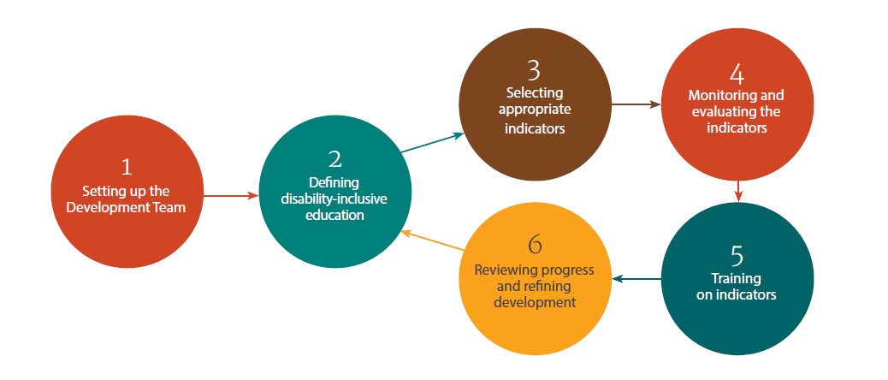
Table 1 Pacific Indicators for Measuring Disability-Inclusive Education (Pacific-INDIE) in the Pacific Island Countries
No | Indicator | PEDF Strategic Objectives
1 | Policy and Legislation  Outcome: Children’s right to disability-inclusive education is supported by legislation and/or policy
1.1 | Existence of legislation and/or policy that clearly articulates right to appropriate education for all children with disabilities. | E
1.2 | Percentage of education budget spent on implementation of disability-inclusive education plan at the local level. | E
1.3 | A national disability-inclusive education implementation plan is developed and aligned with relevant legislation and/or policy. | E
1.4 | A national disability-inclusive education implementation plan is approved by the relevant Ministry. | E
1.5 | Percentage of schools that have implemented a national/provincial disability-inclusive education plan. | E
2 | Awareness of the Rights of Children with Disabilities  Outcome: Communities are responsive to the rights of children with disabilities and their families, and the benefits of disability-inclusive education to the society
2.1 | Number of community awareness programs focused on out of school children with disabilities. | E
2.2 | Number of disability awareness programs designed and implemented in partnership with DPOs. | E
2.3 | Number of parent education programs for supporting their children with disabilities. | A
3 | Education, Training and Professional Development  Outcome: The workforce is competent and committed to implement disability-inclusive education
3.1 | Teacher training curriculum includes a mandatory course on disability-inclusive education. | Q
3.2 | Teacher education programs include disability-inclusive education practicum experiences. | Q
3.3 | Percentage of teachers in service who have received training in the last 12 months to teach students with disabilities. | Q
3.4 | Number of teacher assistants who have completed accredited programs in disability-inclusive education. | E

Notes: Pacific Education Development Framework (PEDF) Strategic Objectives: A = Access; Q = Quality; E = Efficiency and Effectiveness; Children with disabilities = Children and Youth with Disabilities. The indicators written in italics are highly recommended for obtaining an overview of disability-inclusive education within each country.
No | Indicator | PEDF Strategic Objective
4 | Presence and Achievement  Outcome: Increased enrolment and attendance of children with disabilities in education facilities
4.1 | Number of regular schools enrolling children with disabilities. | A
4.2 | Number of children with disabilities completing primary school. | A
4.3 | Number of children with disabilities completing secondary school. | A
4.4 | Number of children with disabilities enrolled in regular primary and secondary schools. | A
4.5 | Percentage of new enrolments of children with disabilities as a proportion of new entrants in regular schools. | A
4.6 | Percentage of children with disability attending school regularly. | A
4.7 | Number of students with disability meeting grade appropriate literacy standards in national/school-based/district wide tests. | Q
4.8 | Number of students with disability meeting grade appropriate numeracy standards in national/school-based tests. | Q
4.9 | Number of children with disabilities dropping out of school. | A
4.10 | Number of dropped out children with disabilities who have re-enrolled. | A
4.11 | Number of children with disabilities enrolled in Non-Formal Education (NFE) programs. | A
4.12 | Number of children with disabilities accessing incentive programs for education. | Q
5 | Physical Environment and Transport  Outcome: Education facilities are accessible to children with disabilities
5.1 | Percentage of schools (primary, lower and upper secondary) with adapted infrastructure and materials for students with disabilities. | Q
5.2 | Number of school transport vehicles that are accessible for children with disabilities. | A
6 | Identification  Outcome: Children with disabilities are identified through referral or screening processes
6.1 | Education Management Information System (EMIS) records data on children with disabilities. | E
6.2 | Number of schools reporting on the number of children with disabilities to the Ministry. | E
6.3 | Number of parent information sessions on referral processes. | E
6.4 | Number of schools conducting a disability screening program. | Q
7 | Early Intervention and Services  Outcome: Children with disabilities receive timely access to appropriate disability services including early intervention
7.1 | Number of children with disabilities who are provided with relevant assistive devices and technologies. | Q
7.2 | Number of schools that have used a referral system to access early intervention services. | A
7.3 | Number of schools that have made referrals to health and rehabilitation services. | E
7.4 | Number of schools with access to specialists to support inclusion of children with disabilities. | Q
7.5 | Number of specialist staff available to support disability-inclusive education. | E
8 | Collaboration, Shared Responsibility and Self-Advocacy  Outcome: Collaborative efforts are made between Ministry, schools, special schools, service providers, DPOs, community organisations and families to enhance disability-inclusive education for children with disabilities
8.1 | Formal processes are established to systematically involve parents of children with disabilities in educational programs. | E
8.2 | Number of meetings involving parents of children with disabilities. | Q
8.3 | Number of schools with a collaborative inclusive education committee/team. | E
8.4 | Number of regular schools collaborating with stakeholders to facilitate disability-inclusive education. | E
8.5 | Number of children with disabilities and families who have received self-advocacy training. | E
8.6 | Advocacy mechanisms are in place to support children with severe intellectual disability or psychological disorders which prevent self-advocacy. | Q
8.7 | Number of children with disabilities accessing training specific to their needs. | A
Notes: Pacific Education Development Framework (PEDF) Strategic Objectives: A = Access; Q = Quality; E = Efficiency and Effectiveness; Children with disabilities = Children and Youth with Disabilities. The indicators written in italics are highly recommended for obtaining an overview of disability-inclusive education within each country.
No | Indicator | PEDF Strategic Objective
9 | Curriculum and Assessment Practices  Outcome: School curriculum and assessment processes are inclusive and acknowledge the diverse learning needs of children with disabilities
9.1 | Number of children with disabilities being assessed against the national curriculum. | Q
9.2 | Number of children with disabilities who sit exams with reasonable accommodations. | Q
10 | Transition Pathways  Outcome: Children with disabilities transition through the various educational settings from early childhood to post-secondary options
10.1 | Number of children with disabilities graduating at an age-appropriate level and transitioning from primary to secondary school. | A
10.2 | Number of children with disabilities transitioning from special schools to regular schools. | A
10.3 | Number of children with disabilities graduating at an age-appropriate level and transitioning from secondary to higher education and/or employment. | A
10.4 | Number of students with disabilities accessing post-school options. | A
Notes: Pacific Education Development Framework (PEDF) Strategic Objectives: A = Access; Q = Quality; E = Efficiency and Effectiveness; Children with disabilities = Children and Youth with Disabilities. The indicators written in italics are highly recommended for obtaining an overview of disability-inclusive education within each country.

Contact us
For more information about this program please contact the Principal Investigator:

Associate Professor Umesh Sharma
Email: Umesh.Sharma@monash.edu
Phone: +61 3 990 54388
29 Ancora Imparo Way, Faculty of Education, Clayton Campus Monash University Victoria 3800 Australia

